Core J2EE Patterns: Patterns index page
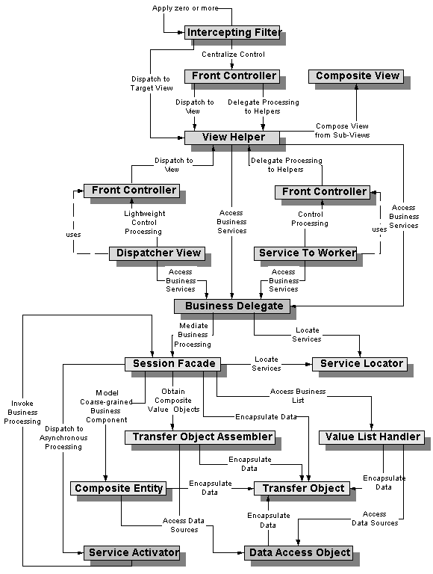

Core J2EE Patterns - Intercepting Filter

Context
The presentation-tier request handling mechanism receives many different types of requests, which require varied types of processing. Some requests are simply forwarded to the appropriate handler component, while other requests must be modified, audited, or uncompressed before being further processed.

Problem
Preprocessing and post-processing of a client Web request and response are required.
When a request enters a Web application, it often must pass several entrance tests prior to the main processing stage. For example,
- Has the client been authenticated?
- Does the client have a valid session?
- Is the client's IP address from a trusted network?
- Does the request path violate any constraints?
- What encoding does the client use to send the data?
- Do we support the browser type of the client?
Some of these checks are tests, resulting in a yes or no answer that determines whether processing will continue. Other checks manipulate the incoming data stream into a form suitable for processing.
The classic solution consists of a series of conditional checks, with any failed check aborting the request. Nested if/else statements are a standard strategy, but this solution leads to code fragility and a copy-and-paste style of programming, because the flow of the filtering and the action of the filters is compiled into the application.
The key to solving this problem in a flexible and unobtrusive manner is to have a simple mechanism for adding and removing processing components, in which each component completes a specific filtering action.

Forces
- Common processing, such as checking the data-encoding scheme or logging information about each request, completes per request.
- Centralization of common logic is desired.
- Services should be easy to add or remove unobtrusively without affecting existing components, so that they can be used in a variety of combinations, such as
  - Logging and authentication
  - Debugging and transformation of output for a specific client
  - Uncompressing and converting encoding scheme of input

Solution
Create pluggable filters to process common services in a standard manner without requiring changes to core request processing code. The filters intercept incoming requests and outgoing responses, allowing preprocessing and post-processing. We are able to add and remove these filters unobtrusively, without requiring changes to our existing code.
We are able, in effect, to decorate our main processing with a variety of common services, such as security, logging, debugging, and so forth. These filters are components that are independent of the main application code, and they may be added or removed declaratively. For example, a deployment configuration file may be modified to set up a chain of filters. The same configuration file might include a mapping of specific URLs to this filter chain. When a client requests a resource that matches this configured URL mapping, the filters in the chain are each processed in order before the requested target resource is invoked.

Structure
Figure 7.1 represents the Intercepting Filter pattern.
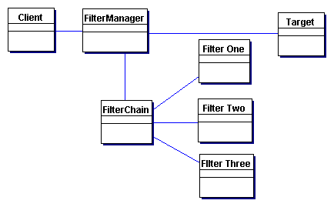
Figure 7.1 Intercepting Filter pattern class diagram

Participants and Responsibilities
Figure 7.2 represents the Intercepting Filter pattern.
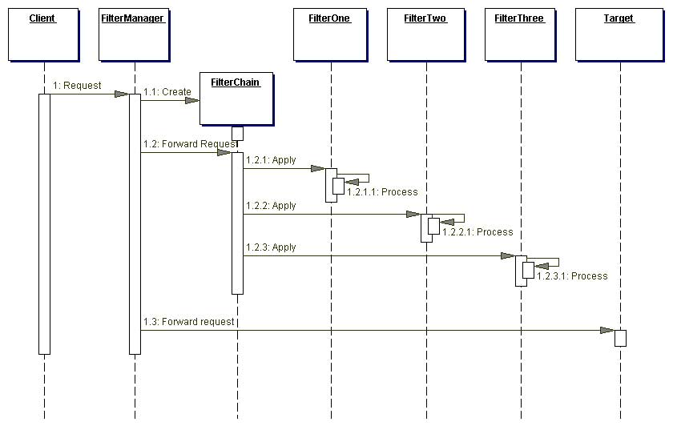
Figure 7.2 Intercepting Filter sequence diagram

FilterManager
The FilterManager manages filter processing. It creates the FilterChain with the appropriate filters, in the correct order, and initiates processing.

FilterChain
The FilterChain is an ordered collection of independent filters.

FilterOne, FilterTwo, FilterThree
These are the individual filters that are mapped to a target. The FilterChain coordinates their processing.

Target
The Target is the resource requested by the client.

Strategies

Custom Filter Strategy
Filter is implemented via a custom strategy defined by the developer. This is less flexible and less powerful than the preferred Standard Filter Strategy, which is presented in the next section and is only available in containers supporting the 2.3 servlet specification. The Custom Filter Strategy is less powerful because it cannot provide for the wrapping of request and response objects in a standard and portable way. Additionally, the request object cannot be modified, and some sort of buffering mechanism must be introduced if filters are to control the output stream. To implement the Custom Filter Strategy, the developer could use the Decorator pattern [GoF] to wrap filters around the core request processing logic. For example, there may be a debugging filter that wraps an authentication filter. Example 7.1 and Example 7.2 show how this mechanism might be created programmatically:
Example 7.1 Implementing a Filter - Debugging Filter
public class DebuggingFilter implements Processor {
private Processor target;

public DebuggingFilter(Processor myTarget) {
target = myTarget;
}

public void execute(ServletRequest req,
ServletResponse res) throws IOException,
ServletException {
//Do some filter processing here, such as
// displaying request parameters
target.execute(req, res);
}
}

Example 7.2 Implementing a Filter - Core Processor
public class CoreProcessor implements Processor {
private Processor target;
public CoreProcessor() {
this(null);
}

public CoreProcessor(Processor myTarget) {
target = myTarget;
}

public void execute(ServletRequest req,
ServletResponse res) throws IOException,
ServletException {
//Do core processing here
}
}

In the servlet controller, we delegate to a method called processRequest to handle incoming requests, as shown in Example 7.3.
Example 7.3 Handling Requests
public void processRequest(ServletRequest req,
ServletResponse res)
throws IOException, ServletException {
Processor processors = new DebuggingFilter(
new AuthenticationFilter(new CoreProcessor()));
processors.execute(req, res);

//Then dispatch to next resource, which is probably
// the View to display
dispatcher.dispatch(req, res);
}

For example purposes only, imagine that each processing component writes to standard output when it is executed. Example 7.4 shows the possible execution output.
Example 7.4 Messages Written to Standard Output
Debugging filter preprocessing completed...
Authentication filter processing completed...
Core processing completed...
Debugging filter post-processing completed...
A chain of processors is executed in order. Each processor, except for the last one in the chain, is considered a filter. The final processor component is where we encapsulate the core processing we want to complete for each request. Given this design, we will need to change the code in the CoreProcessor class, as well as in any filter classes, when we want to modify how we handle requests.
Figure 7.3 is a sequence diagram describing the flow of control when using the filter code of Example 7.1, Example 7.2, and Example 7.3.
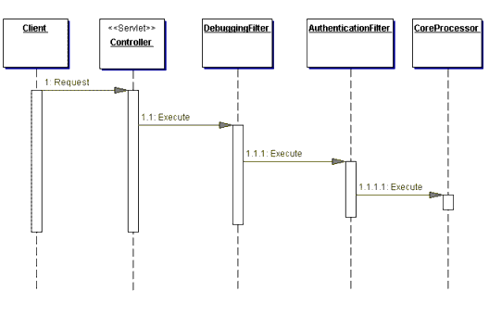
Figure 7.3 Sequence diagram for Custom Filter Strategy, decorator implementation
Notice that when we use a decorator implementation, each filter invokes on the next filter directly, though using a generic interface. Alternatively, this strategy can be implemented using a FilterManager and FilterChain. In this case, these two components coordinate and manage filter processing and the individual filters do not communicate with one another directly. This design approximates that of a servlet 2.3-compliant implementation, though it is still a custom strategy. Example 7.5 is the listing of just such a FilterManager class that creates a FilterChain, which is shown in Example 7.6. The FilterChain adds filters to the chain in the appropriate order (for the sake of brevity, this is done in the FilterChain constructor, but would normally be done in place of the comment), processes the filters, and finally processes the target resource. Figure 7.4 is a sequence diagram for this code.
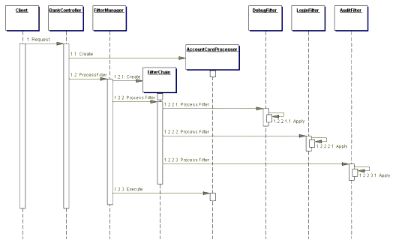
Figure 7.4 Sequence diagram for Custom Filter Strategy, nondecorator implementation
Example 7.5 FilterManager - Custom Filter Strategy
public class FilterManager {
public void processFilter(Filter target,
javax.servlet.http.HttpServletRequest request,
javax.servlet.http.HttpServletResponse response)
throws javax.servlet.ServletException,
java.io.IOException {
FilterChain filterChain = new FilterChain();

// The filter manager builds the filter chain here
// if necessary

// Pipe request through Filter Chain
filterChain.processFilter(request, response);

//process target resource
target.execute(request, response);
}
}

Example 7.6 FilterChain - Custom Filter Strategy
public class FilterChain {
// filter chain
private Vector myFilters = new Vector();

// Creates new FilterChain
public FilterChain() {
// plug-in default filter services for example
// only. This would typically be done in the
// FilterManager, but is done here for example
// purposes
addFilter(new DebugFilter());
addFilter(new LoginFilter());
addFilter(new AuditFilter());
}

public void processFilter(
javax.servlet.http.HttpServletRequest request,
javax.servlet.http.HttpServletResponse response)
throws javax.servlet.ServletException,
java.io.IOException {
Filter filter;

// apply filters
Iterator filters = myFilters.iterator();
while (filters.hasNext())
{
filter = (Filter)filters.next();
// pass request & response through various
// filters
filter.execute(request, response);
}
}

public void addFilter(Filter filter) {
myFilters.add(filter);
}
}

This strategy does not allow us to create filters that are as flexible or as powerful as we would like. For one, filters are added and removed programmatically. While we could write a proprietary mechanism for handling adding and removing filters via a configuration file, we still would have no way of wrapping the request and response objects. Additionally, without a sophisticated buffering mechanism, this strategy does not provide flexible postprocessing.
The Standard Filter Strategy provides solutions to these issues, leveraging features of the 2.3 Servlet specification, which has provided a standard solution to the filter dilemma.
Note
As of this writing, the Servlet 2.3 specification is in final draft form.

Standard Filter Strategy
Filters are controlled declaratively using a deployment descriptor, as described in the servlet specification version 2.3, which, as of this writing, is in final draft form. The servlet 2.3 specification includes a standard mechanism for building filter chains and unobtrusively adding and removing filters from those chains. Filters are built around interfaces, and added or removed in a declarative manner by modifying the deployment descriptor for a Web application.
Our example for this strategy will be to create a filter that preprocesses requests of any encoding type such that each request may be handled similarly in our core request handling code. Why might this be necessary? HTML forms that include a file upload use a different encoding type than that of most forms. Thus, form data that accompanies the upload is not available via simple getParameter() invocations. So, we create two filters that preprocess requests, translating all encoding types into a single consistent format. The format we choose is to have all form data available as request attributes.
One filter handles the standard form encoding of type application/ x-www-form-urlencoded and the other handles the less common encoding type multipart/form-data, which is used for forms that include file uploads. The filters translate all form data into request attributes, so the core request handling mechanism can work with every request in the same manner, instead of with special casing for different encodings.
Example 7.8 shows a filter that translates requests using the common application form encoding scheme. Example 7.9 shows the filter that handles the translation of requests that use the multipart form encoding scheme. The code for these filters is based on the final draft of the servlet specification, version 2.3. A base filter is used as well, from which both of these filters inherit (see the section "Base Filter Strategy"). The base filter, shown in Example 7.7, provides default behavior for the standard filter callback methods.
Example 7.7 Base Filter - Standard Filter Strategy
public class BaseEncodeFilter implements
javax.servlet.Filter {
private javax.servlet.FilterConfig myFilterConfig;

public BaseEncodeFilter() { }

public void doFilter(
javax.servlet.ServletRequest servletRequest,
javax.servlet.ServletResponse servletResponse,
javax.servlet.FilterChain filterChain)
throws java.io.IOException,
javax.servlet.ServletException {
filterChain.doFilter(servletRequest,
servletResponse);
}

public javax.servlet.FilterConfig getFilterConfig()
{
return myFilterConfig;
}

public void setFilterConfig(
javax.servlet.FilterConfig filterConfig) {
myFilterConfig = filterConfig;
}
}

Example 7.8 StandardEncodeFilter - Standard Filter Strategy
public class StandardEncodeFilter
extends BaseEncodeFilter {
// Creates new StandardEncodeFilter
public StandardEncodeFilter() { }

public void doFilter(javax.servlet.ServletRequest
servletRequest,javax.servlet.ServletResponse
servletResponse,javax.servlet.FilterChain
filterChain)
throws java.io.IOException,
javax.servlet.ServletException {

String contentType =
servletRequest.getContentType();
if ((contentType == null) ||
contentType.equalsIgnoreCase(
"application/x-www-form-urlencoded")) {
translateParamsToAttributes(servletRequest,
servletResponse);
}

filterChain.doFilter(servletRequest,
servletResponse);
}

private void translateParamsToAttributes(
ServletRequest request, ServletResponse response)
{
Enumeration paramNames =
request.getParameterNames();

while (paramNames.hasMoreElements()) {
String paramName = (String)
paramNames.nextElement();

String [] values;

values = request.getParameterValues(paramName);
System.err.println("paramName = " + paramName);
if (values.length == 1)
request.setAttribute(paramName, values[0]);
else
request.setAttribute(paramName, values);
}
}
}

Example 7.9 MultipartEncodeFilter - Standard Filter Strategy
public class MultipartEncodeFilter extends
BaseEncodeFilter {
public MultipartEncodeFilter() { }
public void doFilter(javax.servlet.ServletRequest
servletRequest, javax.servlet.ServletResponse
servletResponse,javax.servlet.FilterChain
filterChain)
throws java.io.IOException,
javax.servlet.ServletException {
String contentType =
servletRequest.getContentType();
// Only filter this request if it is multipart
// encoding
if (contentType.startsWith(
"multipart/form-data")){
try {
String uploadFolder =
getFilterConfig().getInitParameter(
"UploadFolder");
if (uploadFolder == null) uploadFolder = ".";

/** The MultipartRequest class is:
* Copyright (C) 2001 by Jason Hunter
* <jhunter@servlets.com>. All rights reserved.
**/
MultipartRequest multi = new
MultipartRequest(servletRequest,
uploadFolder,
1 * 1024 * 1024 );
Enumeration params =
multi.getParameterNames();
while (params.hasMoreElements()) {
String name = (String)params.nextElement();
String value = multi.getParameter(name);
servletRequest.setAttribute(name, value);
}

Enumeration files = multi.getFileNames();
while (files.hasMoreElements()) {
String name = (String)files.nextElement();
String filename = multi.getFilesystemName(name);
String type = multi.getContentType(name);
File f = multi.getFile(name);
// At this point, do something with the
// file, as necessary
}
}
catch (IOException e)
{
LogManager.logMessage(
"error reading or saving file"+ e);
}
} // end if
filterChain.doFilter(servletRequest,
servletResponse);
} // end method doFilter()
}

The following excerpt in Example 7.10 is from the deployment descriptor for the Web application containing this example. It shows how these two filters are registered and then mapped to a resource, in this case a simple test servlet. Additionally, the sequence diagram for this example is shown in Figure 7.5.
Example 7.10 Deployment Descriptor - Standard Filter Strategy
.
.
.
<filter>
<filter-name>StandardEncodeFilter</filter-name>
<display-name>StandardEncodeFilter</display-name>
<description></description>
<filter-class> corepatterns.filters.encodefilter.
StandardEncodeFilter</filter-class>
</filter>
<filter>
<filter-name>MultipartEncodeFilter</filter-name>
<display-name>MultipartEncodeFilter</display-name>
<description></description>
<filter-class>corepatterns.filters.encodefilter.
MultipartEncodeFilter</filter-class>
<init-param>
<param-name>UploadFolder</param-name>
<param-value>/home/files</param-value>
</init-param>
</filter>
.
.
.
<filter-mapping>
<filter-name>StandardEncodeFilter</filter-name>
<url-pattern>/EncodeTestServlet</url-pattern>
</filter-mapping>
<filter-mapping>
<filter-name>MultipartEncodeFilter</filter-name>
<url-pattern>/EncodeTestServlet</url-pattern>
</filter-mapping>
.
.
.

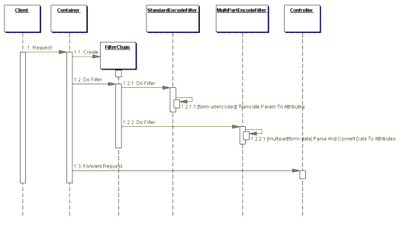
Figure 7.5 Sequence diagram for Intercepting Filter, Standard Filter Strategy - encoding conversion example
The StandardEncodeFilter and the MultiPartEncodeFilter intercept control when a client makes a request to the controller servlet. The container fulfills the role of filter manager and vectors control to these filters by invoking their doFilter methods. After completing its processing, each filter passes control to its containing FilterChain, which it instructs to execute the next filter. Once both of the filters have received and subsequently relinquished control, the next component to receive control is the actual target resource, in this case the controller servlet.
Filters, as supported in version 2.3 of the servlet specification, also support wrapping the request and response objects. This feature provides for a much more powerful mechanism than can be built using the custom implementation suggested by the Custom Filter Strategy. Of course, a hybrid approach combining the two strategies could be custom built as well, but would still lack the power of the Standard Filter Strategy as supported by the servlet specification.

Base Filter Strategy
A base filter serves as a common superclass for all filters. Common features can be encapsulated in the base filter and shared among all filters. For example, a base filter is a good place to include default behavior for the container callback methods in the Declared Filter Strategy. Example 7.11 shows how this can be done.
Example 7.11 Base Filter Strategy
public class BaseEncodeFilter implements
javax.servlet.Filter {
private javax.servlet.FilterConfig myFilterConfig;

public BaseEncodeFilter() { }

public void doFilter(javax.servlet.ServletRequest
servletRequest,javax.servlet.ServletResponse
servletResponse, javax.servlet.FilterChain
filterChain) throws java.io.IOException,
javax.servlet.ServletException {

filterChain.doFilter(servletRequest,
servletResponse);
}

public javax.servlet.FilterConfig getFilterConfig() {
return myFilterConfig;
}

public void
setFilterConfig(javax.servlet.FilterConfig
filterConfig) {
myFilterConfig = filterConfig;
}
}

Template Filter Strategy
Using a base filter from which all others inherit (see "Base Filter Strategy" in this chapter) allows the base class to provide template method [Gof] functionality. In this case, the base filter is used to dictate the general steps that every filter must complete, while leaving the specifics of how to complete that step to each filter subclass. Typically, these would be coarsely defined, basic methods that simply impose a limited structure on each template. This strategy can be combined with any other filter strategy, as well. The listings in Example 7.12 and Example 7.13 show how to use this strategy with the Declared Filter Strategy.
Example 7.12 shows a base filter called TemplateFilter, as follows.
Example 7.12 Using a Template Filter Strategy
public abstract class TemplateFilter implements
javax.servlet.Filter {
private FilterConfig filterConfig;

public void setFilterConfig(FilterConfig fc) {
filterConfig=fc;
}

public FilterConfig getFilterConfig() {
return filterConfig;
}

public void doFilter(ServletRequest request,
ServletResponse response, FilterChain chain)
throws IOException, ServletException {
// Common processing for all filters can go here
doPreProcessing(request, response, chain);

// Common processing for all filters can go here
doMainProcessing(request, response, chain);

// Common processing for all filters can go here
doPostProcessing(request, response, chain);

// Common processing for all filters can go here

// Pass control to the next filter in the chain or
// to the target resource
chain.doFilter(request, response);
}
public void doPreProcessing(ServletRequest request,
ServletResponse response, FilterChain chain) {
}

public void doPostProcessing(ServletRequest request,
ServletResponse response, FilterChain chain) {
}

public abstract void doMainProcessing(ServletRequest
request, ServletResponse response, FilterChain
chain);
}

Given this class definition for TemplateFilter, each filter is implemented as a subclass that must only implement the doMainProcessing method. These subclasses have the option, though, of implementing all three methods if they desire. Example 7.13 is an example of a filter subclass that implements the one mandatory method (dictated by our template filter) and the optional preprocessing method. Additionally, a sequence diagram for using this strategy is shown in Figure 7.6.
Example 7.13 Debugging Filter
public class DebuggingFilter extends TemplateFilter {
public void doPreProcessing(ServletRequest req,
ServletResponse res, FilterChain chain) {
//do some preprocessing here
}

public void doMainProcessing(ServletRequest req,
ServletResponse res, FilterChain chain) {
//do the main processing;
}
}

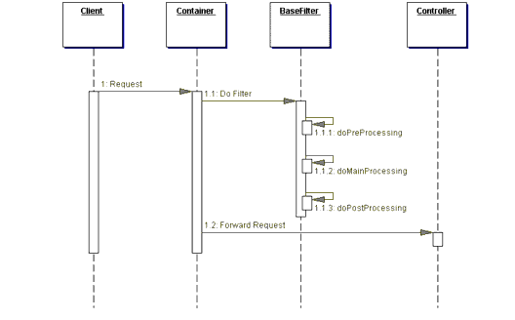
Figure 7.6 Intercepting Filter, Template Filter Strategy sequence diagram
In the sequence diagram in Figure 7.6, filter subclasses, such as DebuggingFilter, define specific processing by overriding the abstract doMainProcessing method and, optionally, doPreProcessing and doPostProcessing. Thus, the template filter imposes a structure to each filter's processing, as well as providing a place for encapsulating code that is common to every filter.

Consequences
- Centralizes Control with Loosely Coupled Handlers
Filters provide a central place for handling processing across multiple requests, as does a controller. Filters are better suited to massaging requests and responses for ultimate handling by a target resource, such as a controller. Additionally, a controller often ties together the management of numerous unrelated common services, such as authentication, logging, encryption, and so forth, while filtering allows for much more loosely coupled handlers, which can be combined in various combinations.
- Improves Reusability
Filters promote cleaner application partitioning and encourages reuse. These pluggable interceptors are transparently added or removed from existing code, and due to their standard interface, they work in any combination and are reusable for varying presentations.
- Declarative and Flexible Configuration
Numerous services are combined in varying permutations without a single recompile of the core code base.
- Information Sharing is Inefficient
Sharing information between filters can be inefficient, since by definition each filter is loosely coupled. If large amounts of information must be shared between filters, then this approach may prove to be costly.

Related Patterns
- Front Controller
The controller solves some similar problems, but is better suited to handling core processing.
- Decorator [GoF]
The Intercepting Filter pattern is related to the Decorator pattern, which provides for dynamically pluggable wrappers.
- Template Method [GoF]
The Template Method pattern is used to implement the Template Filter Strategy.
- Interceptor [POSA2]
The Intercepting Filter pattern is related to the Interceptor pattern, which allows services to be added transparently and triggered automatically.
- Pipes and Filters [POSA1]
The Intercepting Filter pattern is related to the Pipes and Filters pattern.

Core J2EE Patterns - Front Controller

Context
The presentation-tier request handling mechanism must control and coordinate processing of each user across multiple requests. Such control mechanisms may be managed in either a centralized or decentralized manner.

Problem
The system requires a centralized access point for presentation-tier request handling to support the integration of system services, content retrieval, view management, and navigation. When the user accesses the view directly without going through a centralized mechanism, two problems may occur:
- Each view is required to provide its own system services, often resulting in duplicate code.
- View navigation is left to the views. This may result in commingled view content and view navigation.
Additionally, distributed control is more difficult to maintain, since changes will often need to be made in numerous places.

Forces
- Common system services processing completes per request. For example, the security service completes authentication and authorization checks.
- Logic that is best handled in one central location is instead replicated within numerous views.
- Decision points exist with respect to the retrieval and manipulation of data.
- Multiple views are used to respond to similar business requests.
- A centralized point of contact for handling a request may be useful, for example, to control and log a user's progress through the site.
- System services and view management logic are relatively sophisticated.

Solution
Use a controller as the initial point of contact for handling a request. The controller manages the handling of the request, including invoking security services such as authentication and authorization, delegating business processing, managing the choice of an appropriate view, handling errors, and managing the selection of content creation strategies.
The controller provides a centralized entry point that controls and manages Web request handling. By centralizing decision points and controls, the controller also helps reduce the amount of Java code, called scriptlets, embedded in the JavaServer Pages (JSP) page.
Centralizing control in the controller and reducing business logic in the view promotes code reuse across requests. It is a preferable approach to the alternative-embedding code in multiple views-because that approach may lead to a more error-prone, reuse-by-copy- and-paste environment.
Typically, a controller coordinates with a dispatcher component. Dispatchers are responsible for view management and navigation. Thus, a dispatcher chooses the next view for the user and vectors control to the resource. Dispatchers may be encapsulated within the controller directly or can be extracted into a separate component.
While the Front Controller pattern suggests centralizing the handling of all requests, it does not limit the number of handlers in the system, as does a Singleton. An application may use multiple controllers in a system, each mapping to a set of distinct services.

Structure
Figure 7.7 represents the Front Controller class diagram pattern.
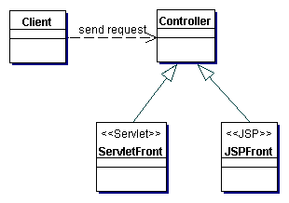
Figure 7.7 Front Controller class diagram

Participants and Responsibilities
Figure 7.8 shows the sequence diagram representing the Front Controller pattern. It depicts how the controller handles a request.
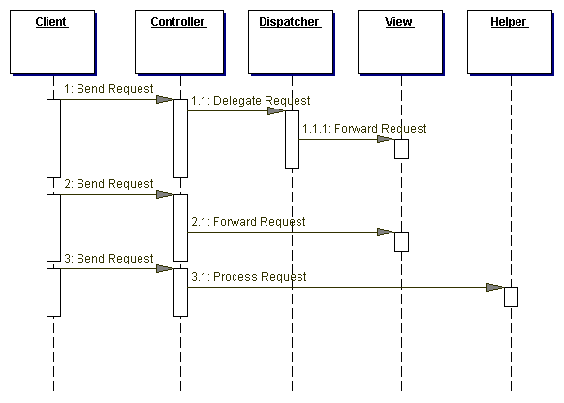
Figure 7.8 Front Controller sequence diagram

Controller
The controller is the initial contact point for handling all requests in the system. The controller may delegate to a helper to complete authentication and authorization of a user or to initiate contact retrieval.

Dispatcher
A dispatcher is responsible for view management and navigation, managing the choice of the next view to present to the user, and providing the mechanism for vectoring control to this resource.
A dispatcher can be encapsulated within a controller or can be a separate component working in coordination. The dispatcher provides either a static dispatching to the view or a more sophisticated dynamic dispatching mechanism.
The dispatcher uses the RequestDispatcher object (supported in the servlet specification) and encapsulates some additional processing.

Helper
A helper is responsible for helping a view or controller complete its processing. Thus, helpers have numerous responsibilities, including gathering data required by the view and storing this intermediate model, in which case the helper is sometimes referred to as a value bean. Additionally, helpers may adapt this data model for use by the view. Helpers can service requests for data from the view by simply providing access to the raw data or by formatting the data as Web content.
A view may work with any number of helpers, which are typically implemented as JavaBeans components (JSP 1.0+) and custom tags (JSP 1.1+). Additionally, a helper may represent a Command object, a delegate (see "Business Delegate" on page 248), or an XSL Transformer, which is used in combination with a stylesheet to adapt and convert the model into the appropriate form.

View
A view represents and displays information to the client. The view retrieves information from a model. Helpers support views by encapsulating and adapting the underlying data model for use in the display.

Strategies
There are several strategies for implementing a controller.

Servlet Front Strategy
This strategy suggests implementing the controller as a servlet. Though semantically equivalent, it is preferred to the JSP Front Strategy. The controller manages the aspects of request handling that are related to business processing and control flow. These responsibilities are related to, but logically independent of, display formatting, and are more appropriately encapsulated in a servlet rather than in a JSP page.
The Servlet Front Strategy does have some potential drawbacks. In particular, it does not leverage some of the JSP runtime environment utilities, such as automatic population of request parameters into helper properties. Fortunately, this drawback is minimal because it is relatively easy to create or obtain similar utilities for general use. There is also the possibility that the functionality of some of the JSP utilities may be included as standard servlet features in a future version of the servlet specification. Example 7.14 is an example of the Servlet Front Strategy.
Example 7.14 Servlet Front Strategy Sample Code
public class EmployeeController extends HttpServlet {
// Initializes the servlet.
public void init(ServletConfig config) throws
ServletException {
super.init(config);
}

// Destroys the servlet.
public void destroy() {
}

/** Processes requests for both HTTP
* <code>GET</code> and <code>POST</code> methods.
* @param request servlet request
* @param response servlet response
*/
protected void processRequest(HttpServletRequest
request, HttpServletResponse response)
throws ServletException, java.io.IOException {
String page;

/**ApplicationResources provides a simple API
* for retrieving constants and other
* preconfigured values**/
ApplicationResources resource =
ApplicationResources.getInstance();
try {

// Use a helper object to gather parameter
// specific information.
RequestHelper helper = new
RequestHelper(request);

Command cmdHelper= helper.getCommand();

// Command helper perform custom operation
page = cmdHelper.execute(request, response);

}
catch (Exception e) {
LogManager.logMessage(
"EmployeeController:exception : " +
e.getMessage());
request.setAttribute(resource.getMessageAttr(),
"Exception occurred : " + e.getMessage());
page = resource.getErrorPage(e);
}
// dispatch control to view
dispatch(request, response, page);
}

/** Handles the HTTP <code>GET</code> method.
* @param request servlet request
* @param response servlet response
*/
protected void doGet(HttpServletRequest request,
HttpServletResponse response)
throws ServletException, java.io.IOException {
processRequest(request, response);
}

/** Handles the HTTP <code>POST</code> method.
* @param request servlet request
* @param response servlet response
*/
protected void doPost(HttpServletRequest request,
HttpServletResponse response)
throws ServletException, java.io.IOException {
processRequest(request, response);
}

/** Returns a short description of the servlet */
public String getServletInfo() {
return "Front Controller Pattern" +
" Servlet Front Strategy Example";
}

protected void dispatch(HttpServletRequest request,
HttpServletResponse response,
String page)
throws javax.servlet.ServletException,
java.io.IOException {
RequestDispatcher dispatcher =
getServletContext().getRequestDispatcher(page);
dispatcher.forward(request, response);
}
}

JSP Front Strategy
This strategy suggests implementing the controller as a JSP page. Though semantically equivalent, the Servlet Front Strategy is preferred to the JSP Front Strategy. Since the controller handles processing that is not specifically related to display formatting, it is a mismatch to implement this component as a JSP page.
Implementing the controller as a JSP page is clearly not preferred for another reason: It requires a software developer to work with a page of markup in order to modify request handling logic. Thus, a software developer will typically find the JSP Front Strategy more cumbersome when completing the cycle of coding, compilation, testing, and debugging. Example 7.15 is an example of the JSP Front Strategy.
Example 7.15 Front Strategy Sample Code
<%@page contentType="text/html"%>
<%@ page import="corepatterns.util.*" %>
<html>
<head><title>JSP Front Controller</title></head>
<body>

<h3><center> Employee Profile </h3>

<%
/**Control logic goes here...
At some point in this code block we retrieve
employee information, encapsulate it within a value
object and place this bean in request scope with the
key "employee". This code has been omitted.

We either dispatch to another JSP at this point or
simply allow the remaining portions of scriptlet
code to execute**/
%>
<jsp:useBean id="employee" scope="request"
class="corepatterns.util.EmployeeTO"/>
<FORM method=POST >
<table width="60%">
<tr>
<td> First Name : </td>
<td> <input type="text"
name="<%=Constants.FLD_FIRSTNAME%>"
value="<jsp:getProperty name="employee"
property="firstName"/>"> </td>
</tr>
<tr>
<td> Last Name : </td>
<td> <input type="text"
name="<%=Constants.FLD_LASTNAME%>"
value="<jsp:getProperty name="employee"
property="lastName"/>"></td>
</tr>
<tr>
<td> Employee ID : </td>
<td> <input type="text" name="<%=Constants.FLD_EMPID%>"
value="<jsp:getProperty name="employee"
property="id"/>"> </td>
</tr>
<tr>
<td> <input type="submit" name="employee_profile"> </td>
<td> </td>
</tr>
</table>
</FORM>

</body>
</html>

Command and Controller Strategy
Based on the Command pattern [GoF], the Command and Controller Strategy suggests providing a generic interface to the helper components to which the controller may delegate responsibility, minimizing the coupling among these components (see "View Helper" on page 33 for more information on helper components). Adding to or changing the work that needs to be completed by these helpers does not require any changes to the interface between the controller and the helpers, but rather to the type and/or content of the commands. This provides a flexible and easily extensible mechanism for developers to add request handling behaviors.
Finally, because the command processing is not coupled to the command invocation, the command processing mechanism may be reused with various types of clients, not just with Web browsers. This strategy also facilitates the creation of composite commands (see Composite pattern [GoF]). See Example 7.16 for sample code and Figure 7.9 for a sequence diagram.
Example 7.16 Command and Controller Strategy Sample Code
/** This processRequest method is invoked from both
* the servlet doGet and doPost methods **/
protected void processRequest(HttpServletRequest
request, HttpServletResponse response)
throws ServletException, java.io.IOException {

String resultPage;
try {
RequestHelper helper = new RequestHelper(request);

/** the getCommand() method internally uses a
factory to retrieve command objects as follows:
Command command = CommandFactory.create(
request.getParameter("op"));
**/
Command command = helper.getCommand();

// delegate request to a command object helper
resultPage = command.execute(request, response);
}
catch (Exception e) {
LogManager.logMessage("EmployeeController",
e.getMessage() );
resultPage = ApplicationResources.getInstance().
getErrorPage(e);
}

dispatch(request, response, resultPage);
}

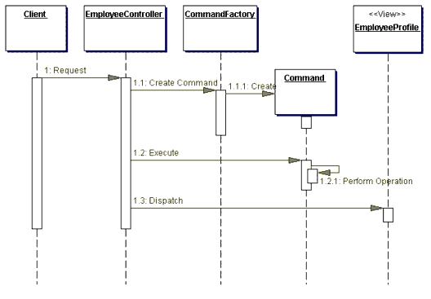
Figure 7.9 Command and Controller Strategy sequence diagram

Physical Resource Mapping Strategy
All requests are made to specific physical resource names rather than logical names. An example is the following URL: http://some.server.com/resource1.jsp. In the case of a controller, an example URL might be http://some.server.com/ servlet/Controller. The Logical Resource Mapping Strategy is typically preferred over this strategy because it provides much greater flexibility. The Logical Resource Mapping Strategy lets you modify resource mappings in a declarative manner, via a configuration file. This is much more flexible than the Physical Resource Mapping Strategy, which requires that you make changes to each resource, as is necessary when implementing this strategy.

Logical Resource Mapping Strategy
Requests are made to logical resource names rather than to specific physical names. The physical resources to which these logical names refer may then be modified in a declarative manner.
For example, the URL http://some.server.com/process may be mapped as follows:
process=resource1.jsp
OR
process=resource2.jsp
OR
process=servletController

Multiplexed Resource Mapping Strategy
This is actually a substrategy of Logical Resource Naming Strategy. This strategy maps not just a single logical name, but an entire set of logical names, to a single physical resource. For example, a wildcard mapping might map all requests that end with .ctrl to a specific handler.
A request and mapping might look as shown in Table 7-1.
Table 7-1
Request | Mapping
http://some.server.com/action.ctrl | *.ctrl = servletController
In fact, this is the strategy JSP page engines use in order to ensure that requests for JSP page resources (that is, resources whose names end in .jsp) are processed by a specific handler.
Additional information can also be added to a request, providing further details to leverage for this logical mapping. See Table 7-2.
Table 7-2
Request | Mapping
http://some.server.com/profile.ctrl?usecase= create | *.ctrl = servletController
A key benefit of using this strategy is that it provides great flexibility when designing your request handling components. When combined with other strategies, such as the Command and Controller Strategy, you can create a powerful request handling framework.
Consider a controller that handles all requests ending in .ctrl, as described above. Also, consider the left side of this dot-delimited resource name (profile in the above example) to be one part of the name of a use case. Now combine this name with the query parameter value (create in the above example). We are signaling our request handler that we want to process a use case called create profile. Our multiplexed resource mapping sends the request to our servletController, which is part of the mapping shown in Table 7-2 . Our controller creates the appropriate command object, as described in the Command and Controller Strategy. How does the controller know the command object to which it should delegate? Leveraging the additional information in the request URI, the controller delegates to the command object that handles profile creation. This might be a ProfileCommand object that services requests for Profile creation and modification, or it might be a more specific ProfileCreationCommand object.

Dispatcher in Controller Strategy
When the dispatcher functionality is minimal, it can be folded into the controller, as shown in Figure 7.10.
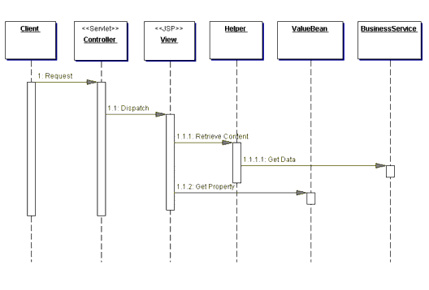
Figure 7.10 Dispatcher in the Controller sequence diagram

Base Front Strategy
Used in combination with the Servlet Front Strategy, this strategy suggests implementing a controller base class, whose implementation other controllers may extend. The base front may contain common and default implementations, while each subclass can override these implementations. The drawback of this strategy is the fact that any shared superclass, while promoting reuse and sharing, raises the issue of creating a fragile hierarchy, where changes necessary for one subclass affect all subclasses.

Filter Controller Strategy
Filters provide similar support for centralizing request processing control (see Intercepting Filter pattern). Thus, some aspects of a controller can reasonably be implemented as a filter. At the same time, filters primarily focus on request interception and decoration, not request processing and response generation. While there are overlapping responsibilities, such as managing logging or debugging, each component complements the other when used appropriately.

Consequences
- Centralizes Control
A controller provides a central place to handle system services and business logic across multiple requests. A controller manages business logic processing and request handling. Centralized access to an application means that requests are easily tracked and logged. Keep in mind, though, that as control centralizes, it is possible to introduce a single point of failure. In practice, this rarely is a problem, though, since multiple controllers typically exist, either within a single server or in a cluster.
- Improves Manageability of Security
A controller centralizes control, providing a choke point for illicit access attempts into the Web application. In addition, auditing a single entrance into the application requires fewer resources than distributing security checks across all pages.
- Improves Reusability
A controller promotes cleaner application partitioning and encourages reuse, as code that is common among components moves into a controller or is managed by a controller.

Related Patterns
- View Helper
The Front Controller pattern, in conjunction with the View Helper pattern, describes factoring business logic out of the view and providing a central point of control and dispatch. Flow logic is factored forward into the controller and data handling code moves back into the helpers.
- Intercepting Filter
Both Intercepting Filter and Front Controller describe ways to centralize control of certain types of request processing, suggesting different approaches to this issue.
- Dispatcher View and Service to Worker
The Dispatcher View and Service to Worker patterns are another way to name the combination of the View Helper pattern with a dispatcher, and Front Controller pattern. Dispatcher View and Service to Worker, while structurally the same, describe different divisions of labor among components.

Core J2EE Patterns - Composite View

Context
Sophisticated Web pages present content from numerous data sources, using multiple subviews that comprise a single display page. Additionally, a variety of individuals with different skill sets contribute to the development and maintenance of these Web pages.

Problem
Instead of providing a mechanism to combine modular, atomic portions of a view into a composite whole, pages are built by embedding formatting code directly within each view.
Modification to the layout of multiple views is difficult and error prone, due to the duplication of code.

Forces
- Atomic portions of view content change frequently.
- Multiple composite views use similar subviews, such as a customer inventory table. These atomic portions are decorated with different surrounding template text, or they appear in a different location within the page.
- Layout changes are more difficult to manage and code harder to maintain when subviews are directly embedded and duplicated in multiple views.
- Embedding frequently changing portions of template text directly into views also potentially affects the availability and administration of the system. The server may need to be restarted before clients see the modifications or updates to these template components.

Solution
Use composite views that are composed of multiple atomic subviews. Each component of the template may be included dynamically into the whole and the layout of the page may be managed independently of the content.
This solution provides for the creation of a composite view based on the inclusion and substitution of modular dynamic and static template fragments. It promotes the reuse of atomic portions of the view by encouraging modular design. It is appropriate to use a composite view to generate pages containing display components that may be combined in a variety of ways. This scenario occurs, for example, with portal sites that include numerous independent subviews, such as news feeds, weather information, and stock quotes on a single page. The layout of the page is managed and modified independent of the subview content.
Another benefit of this pattern is that Web designers can prototype the layout of a site, plugging static content into each of the template regions. As site development progresses, the actual content is substituted for these placeholders.
Figure 7.17 shows a screen capture of Sun's Java Software homepage, java.sun.com. Four regions are identified: Navigation, Search, Feature Story, and Headlines. While the content for each of these component subviews may originate from different data sources, they are laid out seamlessly to create a single composite page.
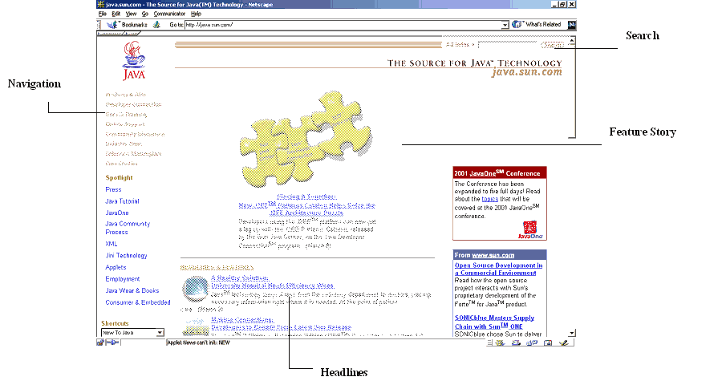
Figure 7.17 Screen shot of a modular page, including Search, Navigation, Feature Story, and Headlines regions
This pattern is not without its drawbacks. There is a runtime overhead associated with it, a tradeoff for the increased flexibility that it provides. Also, the use of a more sophisticated layout mechanism brings with it some manageability and development issues, since there are more artifacts to maintain and a level of implementation indirection to understand.

Structure
Figure 7.18 shows the class diagram that represents the Composite View pattern.
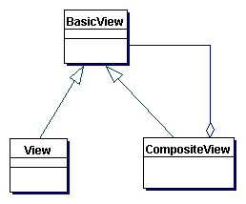
Figure 7.18 Composite View class diagram

Participants and Responsibilities
Figure 7.19 shows the sequence diagram for the Composite View pattern.
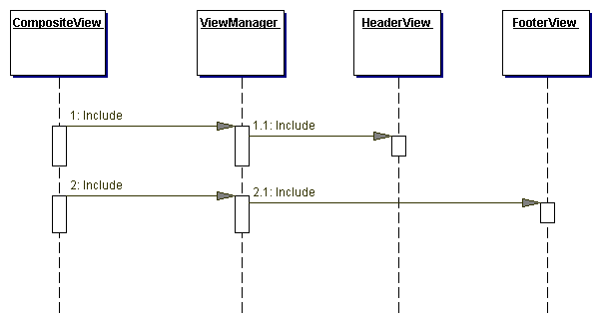
Figure 7.19 Composite View sequence diagram

Composite View
A composite view is a view that is an aggregate of multiple subviews.

View Manager
The View Manager manages the inclusion of portions of template fragments into the composite view. The View Manager may be part of a standard JSP page runtime engine, in the form of the standard JavaServer Pages (JSP page) pages include tag (<jsp:include>), or it may be encapsulated in a JavaBean helper (JSP page 1.0+) or custom tag helper (JSP page 1.1+) to provide more robust functionality.
A benefit of using a mechanism other than the standard include tag is that conditional inclusion is easily done. For example, certain template fragments may be included only if the user fulfills a particular role or certain system conditions are satisfied. Furthermore, using a helper component as a View Manager allows for more sophisticated control of the page structure as a whole, which is useful for creating reusable page layouts.

Included View
An included view is a subview that is one atomic piece of a larger whole view. This included view could also potentially be a composite, itself including multiple subviews.

Strategies

JSP page View Strategy
See "JSP page View Strategy" on page 190.

Servlet View Strategy
See "Servlet View Strategy" on page 191.

JavaBean View Management Strategy
View management is implemented using JavaBeans components, as shown in Example 7.22. The view delegates to the JavaBean, which implements the custom logic to control view layout and composition. The decisions on page layout may be based on user roles or security policies, making it much more powerful than the standard JSP page page include functionality. While it is semantically equivalent to the Custom Tag View Management Strategy, it is not nearly as elegant, since it introduces scriptlet code into the view.
Using the JavaBean View Management Strategy requires less up-front work than using the preferred Custom Tag View Management Strategy, since it is easier to construct JavaBeans components and integrate them into a JSP page page environment. Additionally, even novice developers understand JavaBeans components. This strategy is also easier from a manageability standpoint, because the completed JavaBeans components are the only resulting artifacts to manage and configure.
Example 7.22 JavaBean View Management Strategy
<%@page
import="corepatterns.compositeview.beanhelper.ContentHelper" %>

<% ContentHelper personalizer = new
ContentHelper(request); %>

<table valign="top" cellpadding="30%" width="100%">
<% if (personalizer.hasWorldNewsInterest() ) { %>
<tr>
<td><jsp:getProperty name="feeder"
property="worldNews"/></td>
</tr>
<%
}
if ( personalizer.hasCountryNewsInterest() ) {
%>
<tr>
<td><jsp:getProperty name="feeder"
property="countryNews"/></td>
</tr>
<%
}

if ( personalizer.hasCustomNewsInterest() ) {
%>
<tr>
<td><jsp:getProperty name="feeder"
property="customNews"/></td>
</tr>
<%
}

if ( personalizer.hasAstronomyInterest() ) {
%>

<tr>
<td><jsp:getProperty name="feeder"
property="astronomyNews"/></td>
</tr>
<%
}
%>
</table>

Standard Tag View Management Strategy
View management is implemented using standard JSP page page tags, such as the <jsp:include> tag. Using standard tags for managing the layout and composition of views is an easy strategy to implement, but does not provide the power and flexibility of the preferred Custom Tag View Management Strategy, since the layout for individual pages remains embedded within that page. Thus, while this strategy allows for the underlying content to vary dynamically, any site-wide layout changes would require individual modifications to numerous JSP page pages. This is shown in Example 7.23.
Example 7.23 Standard Tag View Management Strategy
<html>
<body>
<jsp:include
page="/jsp/CompositeView/javabean/banner.html"
flush="true"/>
<table width="100%">
<tr align="left" valign="middle">
<td width="20%">
<jsp:include
page="/jsp/CompositeView/javabean/ProfilePane.jsp"
flush="true"/>
</td>
<td width="70%" align="center">
<jsp:include
page="/jsp/CompositeView/javabean/mainpanel.jsp"
flush="true"/>
</td>
</tr>
</table>
<jsp:include
page="/jsp/CompositeView/javabean/footer.html"
flush="true"/>
</body>
</html>
When creating a composite display using standard tags, both static content, such as an HTML file, and dynamic content, such as a JSP page page, can be included. Additionally, the content can be included at translation time or at runtime. If the content is included at translation time, then the page display will remain unchanged until the JSP page page is recompiled, at which point any modifications to included content will be visible. In other words, the page is laid out and generated once, each time the JSP page page is recompiled. Example 7.24 shows an excerpt of a JSP page page that generates a composite page in this way, using the standard JSP page page include directive <%@ include %>, which includes content at translation time.
Runtime inclusion of content means that changes to underlying subviews are visible in the composite page the next time a client accesses the page. This is much more dynamic and can be accomplished using the standard JSP page page include tag <jsp:include>, as shown in Example 7.25. There is of course some runtime overhead associated with this type of view generation, but it is the tradeoff for the increased flexibility of on-the-fly content modifications.
Example 7.24 Composite View with Translation-Time Content Inclusion
<table border=1 valign="top" cellpadding="2%"
width="100%">
<tr>
<td><%@ file="news/worldnews.html" %> </td>
</tr>
<tr>
<td><%@ file="news/countrynews.html" %> </td>
</tr>
<tr>
<td><%@ file="news/customnews.html" %> </td>
</tr>
<tr>
<td><%@ file="news/astronomy.html" %> </td>
</tr>
</table>
Example 7.25 Composite View with Runtime Content Inclusion
<table border=1 valign="top" cellpadding="2%"
width="100%">
<tr>
<td><jsp:include page="news/worldnews.jsp" flush="true"/> </td>
</tr>
<tr>
<td><jsp:include page="news/countrynews.jsp" flush="true"/> </td>
</tr>
<tr>
<td><jsp:include page="news/customnews.jsp" flush="true"/> </td>
</tr>
<tr>
<td><jsp:include page="news/astronomy.jsp" flush="true"/> </td>
</tr>
</table>

Custom Tag View Management Strategy
View management is implemented using custom tags (JSP page 1.1+), which is the preferred strategy. Logic implemented within the tag controls view layout and composition. These tags are much more powerful and flexible than the standard JSP page include tag, but also require a higher level of effort. Custom actions can base page layout and composition on such things as user roles or security policies.
Using this strategy requires more upfront work than do the other view management strategies, since custom tag development is more complicated than simply using JavaBeans components or standard tags. Not only is there more complexity in the development process, but there is much more complexity with respect to integrating and managing the completed tags. Using this strategy requires the generation of numerous artifacts, including the tag itself, a tag library descriptor, configuration files, and configuring the environment with these artifacts.
The following JSP page page excerpt shows a possible implementation of this strategy and is excerpted from Example 7.26. Please refer to that code sample for more detail.
<region:render
template='/jsp/CompositeView/templates/portal.jsp'>

<region:put section='banner'
content='/jsp/CompositeView/templates/banner.jsp' />

<region:put section='controlpanel' content=
'/jsp/CompositeView/templates/ProfilePane.jsp' />

<region:put section='mainpanel' content=
'/jsp/CompositeView/templates/mainpanel.jsp' />

<region:put section='footer' content=
'/jsp/CompositeView/templates/footer.jsp' />
</region:render>

Transformer View Management Strategy
View management is implemented using an XSL Transformer. This strategy would typically be combined with the Custom Tag View Management Strategy, using custom tags to implement and delegate to the appropriate components. Using this strategy can help to enforce the separation of the model from the view, since much of the view markup must be factored into a separate stylesheet. At the same time, it involves technologies that require new and sophisticated skill sets to implement correctly, an issue that makes this strategy impractical in many environments where these technologies are not already established.
The following excerpt shows the use of a custom tag from within a JSP page page to convert a model using a stylesheet and transformer:
<xsl:transform model="portfolioHelper"
stylesheet="/transform/styles/generalPortfolio.xsl"/>

Early-Binding Resource Strategy
This is another name for translation-time content inclusion, as described in the Standard Tag View Management Strategy and shown in Example 7.24. It is appropriate for maintaining and updating a relatively static template and is recommended if a view includes headers and footers that change infrequently.

Late-Binding Resource Strategy
This is another name for runtime-content inclusion, as described in the Standard Tag View Management Strategy and shown in Example 7.25. It is appropriate for composite pages that may change frequently. One note: If the subview included at runtime is a dynamic resource, such as a JSP page, then this subview may also be a composite view, including more runtime content. The flexibility offered by such nested composite structures should be weighed against their runtime overhead and considered in light of specific project requirements.

Consequences
- Improves Modularity and Reuse
The pattern promotes modular design. It is possible to reuse atomic portions of a template, such as a table of stock quotes, in numerous views and to decorate these reused portions with different information. This pattern permits the table to be moved into its own module and simply included where necessary. This type of dynamic layout and composition reduces duplication, fosters reuse, and improves maintainability.
- Enhances Flexibility
A sophisticated implementation may conditionally include view template fragments based on runtime decisions, such as user role or security policy.
- Enhances Maintainability and Manageability
It is much more efficient to manage changes to portions of a template when the template is not hardcoded directly into the view markup. When kept separate from the view, it is possible to modify modular portions of template content independent of the template layout. Additionally, these changes are available to the client immediately, depending on the implementation strategy. Modifications to the layout of a page are more easily managed as well, since changes are centralized.
- Reduces Manageability
Aggregating atomic pieces of the display together to create a single view introduces the potential for display errors, since subviews are page fragments. This is a limitation that can become a manageability issue. For example, if a JSP page page is generating an HTML page using a main page that includes three subviews, and the subviews each include the HTML open and close tag (that is, <HTML> and </HTML>), then the composed page will be invalid. Thus, it is important when using this pattern to be aware that subviews must not be complete views. Tag usage must be accounted for quite strictly in order to create valid composite views, and this can become a manageability issue.
- Performance Impact
Generating a display that includes numerous subviews may slow performance. Runtime inclusion of subviews will result in a delay each time the page is served to the client. In an environment with strict Service Level Agreements that mandate specific response times, such performance slowdowns, though typically extremely minimal, may not be acceptable. An alternative is to move the subview inclusion to translation time, though this limits the subview to changing when the page is retranslated.

Sample Code
The Composite View pattern can be implemented using any number of strategies, but one of the more popular is the Custom Tag View Management Strategy. In fact, there are a number of custom tag libraries currently available for implementing composite views that separate view layout from view content and provide for modular and pluggable template subviews.
This sample will use a template library written by David Geary and featured in detail in "Advanced JavaServer Pages" [Geary].
The template library describes three basic components: sections, regions, and templates.
- A section is a reusable component that renders HTML or JSP page.
- A region describes content by defining sections.
- A template controls the layout of regions and sections in a rendered page.
A region can be defined and rendered as shown in Example 7.26.
Example 7.26 A Region and Sections
<region:render template='portal.jsp'>
<region:put section='banner' content = 'banner.jsp' />
<region:put section = 'controlpanel' content =
'ProfilePane.jsp' />
<region:put section='mainpanel' content =
'mainpanel.jsp' />
<region:put section='footer' content='footer.jsp' />
</region:render>

A region defines its content by matching logical section names with a portion of content, such as banner.jsp.
The layout for the region and its sections is defined by a template, to which each region is associated. In this case, the template is named portal.jsp, as defined in Example 7.27.
Example 7.27 Template Definition
<region:render section='banner'/>
<table width="100%">
<tr align="left" valign="middle">
<td width="20%">
<!-- menu region -->
<region:render section='controlpanel' />
</td>
<td width="70%" align="center">
<!-- contents -->
<region:render section='mainpanel' />
</td>
</tr>
</table>

A site with numerous views and a single consistent layout has one JSP page containing code that looks similar to the template definition in Example 7.27, and many JSP page pages that look similar to Example 7.26, defining alternate regions and sections.
Sections are JSP page page fragments that are used as subviews to build a composite whole as defined by a template. The banner.jsp section is shown in Example 7.28.
Example 7.28 Section Subview - banner.jsp
<table width="100%" bgcolor="#C0C0C0">
<tr align="left" valign="middle">
<td width="100%">

<TABLE ALIGN="left" BORDER=1 WIDTH="100%">
<TR ALIGN="left" VALIGN="middle">
<TD>Logo</TD>
<TD><center>Sun Java Center</TD>
</TR>
</TABLE>

</td>
</tr>
</table>

Composite views are a modular, flexible and extensible way to build JSP page page views for your J2EE application.

Related Patterns
- View Helper
The Composite View pattern may be used as the view in the View Helper pattern.
- Composite [GoF]The Composite View pattern is based on the Composite pattern, which describes part-whole hierarchies where a composite object is comprised of numerous pieces, all of which are treated as logically equivalent.

Core J2EE Patterns - View Helper

Context
The system creates presentation content, which requires processing of dynamic business data.

Problem
Presentation tier changes occur often and are difficult to develop and maintain when business data access logic and presentation formatting logic are interwoven. This makes the system less flexible, less reusable, and generally less resilient to change.
Intermingling the business and systems logic with the view processing reduces modularity and also provides a poor separation of roles among Web production and software development teams.

Forces
- Business data assimilation requirements are nontrivial.
  - Embedding business logic in the view promotes a copy-and-paste type of reuse. This causes maintenance problems and bugs because a piece of logic is reused in the same or different view by simply duplicating it in the new location.
  - It is desirable to promote a clean separation of labor by having different individuals fulfill the roles of software developer and Web production team member.
  - One view is commonly used to respond to a particular business request.

Solution
A view contains formatting code, delegating its processing responsibilities to its helper classes, implemented as JavaBeans or custom tags. Helpers also store the view's intermediate data model and serve as business data adapters.
There are multiple strategies for implementing the view component. The JSP View Strategy suggests using a JSP as the view component. This is the preferred strategy, and it is the one most commonly used. The other principal strategy is the Servlet View Strategy, which utilizes a servlet as the view (see the section "Strategies" for more information).
Encapsulating business logic in a helper instead of a view makes our application more modular and facilitates component reuse. Multiple clients, such as controllers and views, may leverage the same helper to retrieve and adapt similar model state for presentation in multiple ways. The only way to reuse logic embedded in a view is by copying and pasting it elsewhere. Furthermore, copy-and-paste duplication makes a system harder to maintain, since the same bug potentially needs to be corrected in multiple places.
A signal that one may need to apply this pattern to existing code is when scriptlet code dominates the JSP view. The overriding goal when applying this pattern, then, is the partitioning of business logic outside of the view. While some logic is best encapsulated within helper objects, other logic is better placed in a centralized component that sits in front of the views and the helpers-this might include logic that is common across multiple requests, such as authentication checks or logging services, for example. Refer to the "Intercepting Filter" on page 4 and "Front Controller" on page 21 for more information on these issues.
If a separate controller is not employed in the architecture, or is not used to handle all requests, then the view component becomes the initial contact point for handling some requests. For certain requests, particularly those involving minimal processing, this scenario works fine. Typically, this situation occurs for pages that are based on static information, such as the first of a set of pages that will be served to a user to gather some information (see "Dispatcher View" on page 232). Additionally, this scenario occurs in some cases when a mechanism is employed to create composite pages (see "Composite View" on page 203).
The View Helper pattern focuses on recommending ways to partition your application responsibilities. For related discussions about issues dealing with directing client requests directly to a view, please refer to the section "Dispatcher View" on page 232.

Structure
Figure 7.11 is the class diagram representing the View Helper pattern.
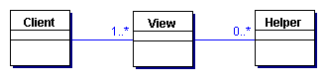
Figure 7.11 View Helper class diagram

Participants and Responsibilities
Figure 7.12 shows the sequence diagram representing the View Helper pattern. A controller typically mediates between the client and the view. In some cases, though, a controller is not used and the view becomes the initial contact point for handling the request. (Also, see Dispatcher View pattern.)
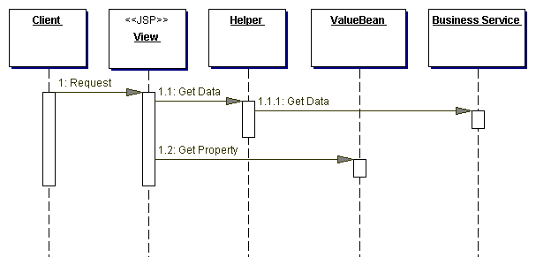
Figure 7.12 View Helper sequence diagram
As noted in the class diagram, there may be no helpers associated with a view. In this simple case, the page may be entirely static or include very small amounts of inline scriptlet code. This scenario is described in the sequence diagram in Figure 7.13.
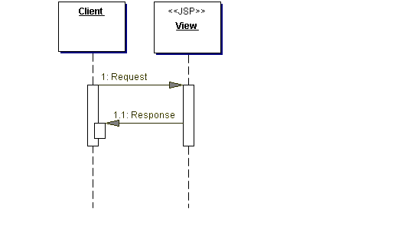
Figure 7.13 View Helper simple sequence diagram

View
A view represents and displays information to the client. The information that is used in a dynamic display is retrieved from a model. Helpers support views by encapsulating and adapting a model for use in a display.

Helper
A helper is responsible for helping a view or controller complete its processing. Thus, helpers have numerous responsibilities, including gathering data required by the view and storing this intermediate model, in which case the helper is sometimes referred to as a value bean. Additionally, helpers may adapt this data model for use by the view. Helpers can service requests for data from the view by simply providing access to the raw data or by formatting the data as Web content.
A view may work with any number of helpers, which are typically implemented as JavaBeans (JSP 1.0+) and custom tags (JSP 1.1+). Additionally, a helper may represent a Command object, a delegate (see "Business Delegate" on page 248), or an XSL Transformer, which is used in combination with a stylesheet to adapt and convert the model into the appropriate form.

ValueBean
A value bean is another name for a helper that is responsible for holding intermediate model state for use by a view. A typical case, as shown in the sequence diagram in Figure 7.12, has the business service returning a value bean in response to a request. In this case, ValueBean fulfills the role of a Transfer Object (see "Transfer Object" on page 261).

BusinessService
The business service is a role that is fulfilled by the service the client is seeking to access. Typically, the business service is accessed via a Business delegate. The business delegate's role is to provide control and protection for the business service (see the "Business Delegate" on page 248).

Strategies

JSP View Strategy
The JSP View Strategy suggests using a JSP as the view component. This is the preferred strategy to the Servlet View Strategy. While it is semantically equivalent to the Servlet View Strategy, it is a more elegant solution and is more commonly used. Views are the domain of Web designers, who prefer markup to Java code. Example 7.17 shows a code sample for this strategy. The excerpt is from a source file called welcome.jsp, to which a servlet controller dispatches after placing the WelcomeHelper JavaBean in request scope.
Example 7.17 JSP View Strategy Sample Code
<jsp:useBean id="welcomeHelper" scope="request"
class="corepatterns.util.WelcomeHelper" />

<HTML>
<BODY bgcolor="FFFFFF">
<% if (welcomeHelper.nameExists())
{
%>
<center><H3> Welcome <b>
<jsp:getProperty name="welcomeHelper" property="name" />
</b><br><br> </H3></center>
<%
}
%>

<H4><center>Glad you are visiting our
site!</center></H4>

</BODY>
</HTML>

The alternative Servlet View Strategy is typically implemented by embedding HTML markup directly within Java Servlet code. Intermingling Java code and markup tags creates a poor separation of user roles within a project and increases the dependencies on the same resources among multiple members of different teams. When an individual works on a template containing unfamiliar code or tags, it increases the likelihood of an accidental change introducing problems into the system. There is also a reduction in work environment efficiency (too many people sharing the same physical resource) and an increase in source control management complexity.
These problems are more likely to occur in larger enterprise environments that have more complicated system requirements and that use teams of developers. They are less likely to occur with small systems that have simple business requirements and use few developers, because the same individual may likely fill the roles mentioned above. However, keep in mind that projects often start small-with simple requirements and few developers-but may ultimately evolve to become sophisticated enough to benefit from these suggestions.

Servlet View Strategy
The Servlet View Strategy utilizes a servlet as the view. It is semantically equivalent to the preferred JSP View Strategy. However, the Servlet View Strategy, as seen in Example 7.18, is often more cumbersome for the software development and Web production teams because it embeds markup tags directly within the Java code. When tags are embedded within the code, the view template is more difficult to update and modify.

Example 7.18 Servlet View Strategy Sample Code
public class Controller extends HttpServlet {
public void init(ServletConfig config) throws
ServletException {
super.init(config);
}

public void destroy() { }

/** Processes requests for both HTTP
* <code>GET</code> and <code>POST</code> methods.
* @param request servlet request
* @param response servlet response
*/
protected void processRequest(HttpServletRequest
request, HttpServletResponse response)
throws ServletException, java.io.IOException {
String title = "Servlet View Strategy";
try {
response.setContentType("text/html");
java.io.PrintWriter out = response.getWriter();
out.println("<html><title>"+title+"</title>");
out.println("<body>");
out.println("<h2><center>Employees List</h2>");
EmployeeDelegate delegate =
new EmployeeDelegate();

/** ApplicationResources provides a simple API
* for retrieving constants and other
* preconfigured values**/
Iterator employees = delegate.getEmployees(
ApplicationResources.getInstance().
getAllDepartments());
out.println("<table border=2>");
out.println("<tr><th>First Name</th>" +
"<th>Last Name</th>" +
"<th>Designation</th><th>Id</th></tr>");
while (employees.hasNext()) {
out.println("<tr>");
EmployeeTO emp = (EmployeeTO)employees.next();
out.println("<td>"+emp.getFirstName()+
"</td>");
out.println("<td>"+emp.getLastName()+
"</td>");
out.println("<td>"+emp.getDesignation()+
"</td>");
out.println("<td>"+emp.getId()+"</td>");
out.println("</tr>");
}
out.println("</table>");
out.println("<br><br>");
out.println("</body>");
out.println("</html>");
out.close();
}
catch (Exception e) {
LogManager.logMessage("Handle this exception",
e.getMessage() );
}
}

/** Handles the HTTP <code>GET</code> method.
* @param request servlet request
* @param response servlet response
*/
protected void doGet(HttpServletRequest request,
HttpServletResponse response)
throws ServletException, java.io.IOException {
processRequest(request, response);
}

/** Handles the HTTP <code>POST</code> method.
* @param request servlet request
* @param response servlet response
*/
protected void doPost(HttpServletRequest request,
HttpServletResponse response)
throws ServletException, java.io.IOException {
processRequest(request, response);
}

/** Returns a short description of the servlet. */
public String getServletInfo() {
return "Example of Servlet View. " +
"JSP View is preferable.";
}

/** dispatcher method **/
protected void dispatch(HttpServletRequest request,
HttpServletResponse response, String page)
throws javax.servlet.ServletException,
java.io.IOException {
RequestDispatcher dispatcher =
getServletContext().getRequestDispatcher(page);
dispatcher.forward(request, response);
}
}

JavaBean Helper Strategy
The helper is implemented as a JavaBean. Using helpers results in a cleaner separation of the view from the business processing in an application, since business logic is factored out of the view and into the helper component. In this case the business logic is encapsulated in a JavaBean, which aids in content retrieval and adapts and stores the model for use by the view.
Using the JavaBean Helper Strategy requires less upfront work than does the Custom Tag Helper Strategy, since JavaBeans are more easily constructed and integrated into a JSP environment. Additionally, even novice developers understand JavaBeans. This strategy is also easier from a manageability standpoint, since the only resulting artifacts are the completed JavaBeans. An example of this strategy is shown in Example 7.19.
Example 7.19 JavaBean Helper Strategy Code Sample
<jsp:useBean id="welcomeHelper" scope="request"
class="corepatterns.util.WelcomeHelper" />

<HTML>
<BODY bgcolor="FFFFFF">
<% if (welcomeHelper.nameExists())
{
%>
<center><H3> Welcome <b>
<jsp:getProperty name="welcomeHelper" property="name" />
</b><br><br> </H3></center>
<%
}
%>

<H4><center>Glad you are visiting our
site!</center></H4>

</BODY>
</HTML>

Custom Tag Helper Strategy
The helper is implemented as a custom tag (JSP 1.1+ only). Using helpers results in a cleaner separation of the view from the business processing in an application, since business logic is factored out of the view and into the helper component. In this case the business logic is encapsulated in a custom tag component, which may aid in content retrieval and adapts the model for use by the view.
Using the Custom Tag Helper Strategy requires more upfront work than does the JavaBean Helper Strategy, since custom tag development is moderately complicated relative to JavaBean development. Not only is there more complexity in the development process, but there is much more complexity with respect to integrating and managing the completed tags. To use this strategy, the environment must be configured with numerous generated artifacts, including the tag itself, a tag library descriptor, and configuration files. An excerpt of a JSP View using this strategy is shown in Example 7.20.
Example 7.20 Custom Tag Helper Strategy Sample Code
<%@ taglib uri="/web-INF/corepatternstaglibrary.tld"
prefix="corepatterns" %>
<html>
<head><title>Employee List</title></head>
<body>

<div align="center">
<h3> List of employees in <corepatterns:department
attribute="id"/> department - Using Custom Tag
Helper Strategy. </h3>
<table border="1" >
<tr>
<th> First Name </th>
<th> Last Name </th>
<th> Designation </th>
<th> Employee Id </th>
<th> Tax Deductibles </th>
<th> Performance Remarks </th>
<th> Yearly Salary</th>
</tr>
<corepatterns:employeelist id="employeelist_key">
<tr>
<td><corepatterns:employee
attribute="FirstName"/> </td>
<td><corepatterns:employee
attribute= "LastName"/></td>
<td><corepatterns:employee
attribute= "Designation"/> </td>
<td><corepatterns:employee
attribute= "Id"/></td>
<td><corepatterns:employee
attribute="NoOfDeductibles"/></td>
<td><corepatterns:employee
attribute="PerformanceRemarks"/></td>
<td><corepatterns:employee
attribute="YearlySalary"/></td>
<td>
</tr>
</corepatterns:employeelist>
</table>
</div>
</body>
</html>

Business Delegate as Helper Strategy
Helper components often make distributed invocations to the business tier. We suggest using a business delegate in order to hide the underlying implementation details of this request, such that the helper simply invokes a business service without knowing details about its physical implementation and distribution (see "Business Delegate" on page 248).
Both a helper and a business delegate may be implemented as a JavaBean. Thus, one could combine the notion of the helper component and the business delegate and implement the business delegate as a specialized type of helper. One major distinction between a helper and a business delegate, though, is as follows: A helper component is written by a developer working in the presentation tier, while the delegate is typically written by a developer working on the services in the business tier. (Note: The delegate may also be provided as part of a framework.) Thus, this strategy is as much about who actually writes the delegate as it is about the implementation. If there is some overlap in developer roles, then the business delegate as helper is a strategy to consider.
Example 7.21 Business Delegate as Helper Strategy Sample Code
/**A servlet delegates to a command object helper, as
shown in the following excerpt:**/
String resultPage = command.execute(request,
response);

/**The command object helper uses the business
delegate, which is simply implemented as another
JavaBean helper, as shown in the following excerpt:**/

AccountDelegate accountDelegate = new
AccountDelegate();

Note on Helpers:
JavaBean helpers are best used for aiding in content retrieval and storing and adapting the model for the view. JavaBean helpers are often used as command objects as well.
Like JavaBean helpers, custom tag helpers may fulfill each of these roles, except for acting as a command object. Unlike JavaBean helpers, custom tag helpers are well suited to control flow and iteration within a view. Custom tag helpers used in this way encapsulate logic that would otherwise be embedded directly within the JSP as scriptlet code. Another area where custom tag helpers are preferred is formatting raw data for display. A custom tag is able to iterate over a collection of results, format those results into an HTML table, and embed the table within a JSP View without requiring any Java Scriptlet code.
Consider an example in which a Web client is requesting account information from a system, as shown in Figure 7.14. There are five helpers shown in this diagram. The four JavaBean helpers are the AccountCommand object, Account object, AccountDAO, and AccountDetails. The sole custom tag helper is the TableFormatter object.
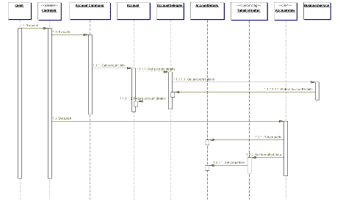
Figure 7.14 Using helpers
The controller handles the request. It creates or looks up the appropriate command object, which is implemented as a JavaBean helper. In this case, it is a command object that processes requests for account information. The controller invokes the Command object, which asks a JavaBean Account object for information about the account. The Account object invokes the business service, asking for these details, which are returned in the form of a Transfer Object (see "Transfer Object" on page 261), implemented as a JavaBean.
So how does the Account object access the business services? Let us examine two cases, one simple and the other more sophisticated. In the simple case, imagine that a project is taking a phased approach, phasing Enterprise JavaBeans (EJB) into the business tier over time. Assume at the moment that the database is being accessed via JDBC calls from the presentation tier. In this case, the Account object uses a Data Access object (see "Data Access Object" on page 390), hiding the underlying implementation details of accessing the database. The Data Access object knows what SQL queries are necessary to retrieve the information. These details are hidden from the rest of the application, reducing coupling and making each component more modular and reusable. This case is described in the previous sequence diagram.
When the architecture becomes more sophisticated, and EJB is introduced in the business tier, then the Data Access object is replaced with a business delegate (see "Business Delegate" on page 248), typically written by the developers of the business service. The delegate hides the implementation details of EJB lookup, invocation, and exception handling from its client. It might also improve performance by providing caching services. Again, the object reduces coupling between tiers, improving the reusability and modularity of the various components. Regardless of the specific implementation of this object, its interface may remain unchanged during this transition. Figure 7.15 describes this scenario after the transition to the business delegate.
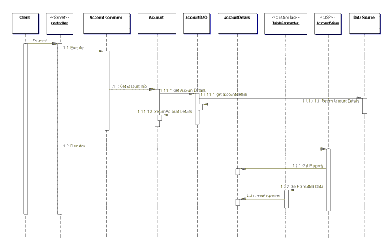
Figure 7.15 Accessing Business Services
The command object now has a handle to the AccountDetails object, which it stores before returning control to the controller. The Controller dispatches to the appropriate view, called AccountView.jsp. The view then grabs a combination of raw data and formatted data from the AccountDetails helper and the TableFormatter helper, respectively. The TableFormatter helper is implemented as a custom tag that cycles through the raw data and formats it into an HTML table for display. As stated, this conversion requires no scriptlet code in the view, which would be necessary to perform the same functionality with a JavaBean helper.
Additionally, the Account object or the AccountDetails helper could provide convenient methods to adapt the raw data in other ways. While such methods would not introduce HTML markup into the data, they might provide different combinations of data. An example is to return the full name of the user in various formats, such as "Lastname, Firstname" or "Firstname Lastname", and so forth.
The completed view is then displayed to the user.

Transformer Helper Strategy
The helper is implemented as an eXtensible Stylesheet Language Transformer. This is particularly useful with models that exist as structured markup, such as eXtensible Markup Language (XML), either natively within legacy systems or via some form of conversion. Using this strategy can help to enforce the separation of the model from the view, since much of the view markup must be factored into a separate stylesheet.
Figure 7.16 describes a potential implementation of this strategy.
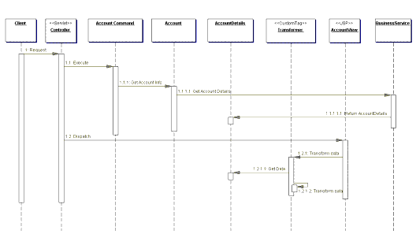
Figure 7.16 Sequence diagram for Transformer Helper Strategy
The controller handles the request and invokes a Command object, implemented as a JavaBean helper. The Command object initiates the retrieval of Account data. The Account object invokes the business service, which returns the data in the form of a Transfer Object (see "Transfer Object" on page 261), implemented as a JavaBean.
Content retrieval is complete and control is dispatched to the AccountView, which uses its custom tag transformer to manipulate the model state. The transformer relies on a stylesheet, which describes how to transform the model, typically describing how to format it with markup for display to the client. The stylesheet is usually retrieved as a static file, though it may also be dynamically generated.
An example of how the custom tag helper might look in AccountView follows:
<xsl:transform model="accounthelper"
stylesheet="/transform/styles/basicaccount.xsl"/>
The integration of eXtensible Stylesheets and XML with JSP is evolving, as tag libraries in this area continue to mature. For now, it is a less preferred strategy, given the immature state of the supporting libraries and the additional sophisticated skills necessary to generate and maintain the stylesheets.

Consequences
- Improves Application Partitioning, Reuse, and Maintainability
Using helpers results in a cleaner separation of the view from the business processing in an application. The helpers, in the form of JavaBeans (JSP 1.0+) and custom tags (JSP 1.1+), provide a place external to the view to encapsulate business logic. Otherwise, scriptlet code clutters the JSP, a cumbersome and unwieldy situation, especially in larger projects.
Additionally, business logic that is factored out of JSPs and into JavaBeans and custom tags is reused, reducing duplication and easing maintenance.
- Improves Role Separation
Separating formatting logic from application business logic reduces dependencies that individuals fulfilling different roles might have on the same resources. For example, a software developer might own code that is embedded within HTML markup, while a Web production team member might need to modify page layout and design components that are intermingled with business logic. Neither individual fulfilling these roles may be familiar with the implementation specifics of the other individual's work, thus raising the likelihood of accidental modifications introducing bugs into the system.

Related Patterns
- Business Delegate
The helper components need to access methods in the business service API. It is also important to reduce the coupling among helpers in the presentation tier and among business services in the business tier. It is recommended that a delegate be used because these tiers may be physically distributed across a network. The delegate hides from the client the underlying details of looking up and accessing the business services, and it may also provide intermediate caching to reduce network traffic.
- Dispatcher View and Service to Worker
When centralized control becomes desirable to handle such issues as security, workflow management, content retrieval, and navigation, consider the Dispatcher View or Service to Worker patterns.
- Front Controller
This pattern is paired with the View Helper pattern to create the Dispatcher View pattern or Service to Worker pattern.

Core J2EE Patterns - Front Controller

Context
The presentation-tier request handling mechanism must control and coordinate processing of each user across multiple requests. Such control mechanisms may be managed in either a centralized or decentralized manner.

Problem
The system requires a centralized access point for presentation-tier request handling to support the integration of system services, content retrieval, view management, and navigation. When the user accesses the view directly without going through a centralized mechanism, two problems may occur:
- Each view is required to provide its own system services, often resulting in duplicate code.
- View navigation is left to the views. This may result in commingled view content and view navigation.
Additionally, distributed control is more difficult to maintain, since changes will often need to be made in numerous places.

Forces
- Common system services processing completes per request. For example, the security service completes authentication and authorization checks.
- Logic that is best handled in one central location is instead replicated within numerous views.
- Decision points exist with respect to the retrieval and manipulation of data.
- Multiple views are used to respond to similar business requests.
- A centralized point of contact for handling a request may be useful, for example, to control and log a user's progress through the site.
- System services and view management logic are relatively sophisticated.

Solution
Use a controller as the initial point of contact for handling a request. The controller manages the handling of the request, including invoking security services such as authentication and authorization, delegating business processing, managing the choice of an appropriate view, handling errors, and managing the selection of content creation strategies.
The controller provides a centralized entry point that controls and manages Web request handling. By centralizing decision points and controls, the controller also helps reduce the amount of Java code, called scriptlets, embedded in the JavaServer Pages (JSP) page.
Centralizing control in the controller and reducing business logic in the view promotes code reuse across requests. It is a preferable approach to the alternative-embedding code in multiple views-because that approach may lead to a more error-prone, reuse-by-copy- and-paste environment.
Typically, a controller coordinates with a dispatcher component. Dispatchers are responsible for view management and navigation. Thus, a dispatcher chooses the next view for the user and vectors control to the resource. Dispatchers may be encapsulated within the controller directly or can be extracted into a separate component.
While the Front Controller pattern suggests centralizing the handling of all requests, it does not limit the number of handlers in the system, as does a Singleton. An application may use multiple controllers in a system, each mapping to a set of distinct services.

Structure
Figure 7.7 represents the Front Controller class diagram pattern.
Figure 7.7 Front Controller class diagram

Participants and Responsibilities
Figure 7.8 shows the sequence diagram representing the Front Controller pattern. It depicts how the controller handles a request.
Figure 7.8 Front Controller sequence diagram

Controller
The controller is the initial contact point for handling all requests in the system. The controller may delegate to a helper to complete authentication and authorization of a user or to initiate contact retrieval.

Dispatcher
A dispatcher is responsible for view management and navigation, managing the choice of the next view to present to the user, and providing the mechanism for vectoring control to this resource.
A dispatcher can be encapsulated within a controller or can be a separate component working in coordination. The dispatcher provides either a static dispatching to the view or a more sophisticated dynamic dispatching mechanism.
The dispatcher uses the RequestDispatcher object (supported in the servlet specification) and encapsulates some additional processing.

Helper
A helper is responsible for helping a view or controller complete its processing. Thus, helpers have numerous responsibilities, including gathering data required by the view and storing this intermediate model, in which case the helper is sometimes referred to as a value bean. Additionally, helpers may adapt this data model for use by the view. Helpers can service requests for data from the view by simply providing access to the raw data or by formatting the data as Web content.
A view may work with any number of helpers, which are typically implemented as JavaBeans components (JSP 1.0+) and custom tags (JSP 1.1+). Additionally, a helper may represent a Command object, a delegate (see "Business Delegate" on page 248), or an XSL Transformer, which is used in combination with a stylesheet to adapt and convert the model into the appropriate form.

View
A view represents and displays information to the client. The view retrieves information from a model. Helpers support views by encapsulating and adapting the underlying data model for use in the display.

Strategies
There are several strategies for implementing a controller.

Servlet Front Strategy
This strategy suggests implementing the controller as a servlet. Though semantically equivalent, it is preferred to the JSP Front Strategy. The controller manages the aspects of request handling that are related to business processing and control flow. These responsibilities are related to, but logically independent of, display formatting, and are more appropriately encapsulated in a servlet rather than in a JSP page.
The Servlet Front Strategy does have some potential drawbacks. In particular, it does not leverage some of the JSP runtime environment utilities, such as automatic population of request parameters into helper properties. Fortunately, this drawback is minimal because it is relatively easy to create or obtain similar utilities for general use. There is also the possibility that the functionality of some of the JSP utilities may be included as standard servlet features in a future version of the servlet specification. Example 7.14 is an example of the Servlet Front Strategy.
Example 7.14 Servlet Front Strategy Sample Code
public class EmployeeController extends HttpServlet {
// Initializes the servlet.
public void init(ServletConfig config) throws
ServletException {
super.init(config);
}

// Destroys the servlet.
public void destroy() {
}

/** Processes requests for both HTTP
* <code>GET</code> and <code>POST</code> methods.
* @param request servlet request
* @param response servlet response
*/
protected void processRequest(HttpServletRequest
request, HttpServletResponse response)
throws ServletException, java.io.IOException {
String page;

/**ApplicationResources provides a simple API
* for retrieving constants and other
* preconfigured values**/
ApplicationResources resource =
ApplicationResources.getInstance();
try {

// Use a helper object to gather parameter
// specific information.
RequestHelper helper = new
RequestHelper(request);

Command cmdHelper= helper.getCommand();

// Command helper perform custom operation
page = cmdHelper.execute(request, response);

}
catch (Exception e) {
LogManager.logMessage(
"EmployeeController:exception : " +
e.getMessage());
request.setAttribute(resource.getMessageAttr(),
"Exception occurred : " + e.getMessage());
page = resource.getErrorPage(e);
}
// dispatch control to view
dispatch(request, response, page);
}

/** Handles the HTTP <code>GET</code> method.
* @param request servlet request
* @param response servlet response
*/
protected void doGet(HttpServletRequest request,
HttpServletResponse response)
throws ServletException, java.io.IOException {
processRequest(request, response);
}

/** Handles the HTTP <code>POST</code> method.
* @param request servlet request
* @param response servlet response
*/
protected void doPost(HttpServletRequest request,
HttpServletResponse response)
throws ServletException, java.io.IOException {
processRequest(request, response);
}

/** Returns a short description of the servlet */
public String getServletInfo() {
return "Front Controller Pattern" +
" Servlet Front Strategy Example";
}

protected void dispatch(HttpServletRequest request,
HttpServletResponse response,
String page)
throws javax.servlet.ServletException,
java.io.IOException {
RequestDispatcher dispatcher =
getServletContext().getRequestDispatcher(page);
dispatcher.forward(request, response);
}
}

JSP Front Strategy
This strategy suggests implementing the controller as a JSP page. Though semantically equivalent, the Servlet Front Strategy is preferred to the JSP Front Strategy. Since the controller handles processing that is not specifically related to display formatting, it is a mismatch to implement this component as a JSP page.
Implementing the controller as a JSP page is clearly not preferred for another reason: It requires a software developer to work with a page of markup in order to modify request handling logic. Thus, a software developer will typically find the JSP Front Strategy more cumbersome when completing the cycle of coding, compilation, testing, and debugging. Example 7.15 is an example of the JSP Front Strategy.
Example 7.15 Front Strategy Sample Code
<%@page contentType="text/html"%>
<%@ page import="corepatterns.util.*" %>
<html>
<head><title>JSP Front Controller</title></head>
<body>

<h3><center> Employee Profile </h3>

<%
/**Control logic goes here...
At some point in this code block we retrieve
employee information, encapsulate it within a value
object and place this bean in request scope with the
key "employee". This code has been omitted.

We either dispatch to another JSP at this point or
simply allow the remaining portions of scriptlet
code to execute**/
%>
<jsp:useBean id="employee" scope="request"
class="corepatterns.util.EmployeeTO"/>
<FORM method=POST >
<table width="60%">
<tr>
<td> First Name : </td>
<td> <input type="text" name="<%=Constants.FLD_FIRSTNAME%>"
value="<jsp:getProperty name="employee"
property="firstName"/>"> </td>
</tr>
<tr>
<td> Last Name : </td>
<td> <input type="text" name="<%=Constants.FLD_LASTNAME%>"
value="<jsp:getProperty name="employee"
property="lastName"/>"></td>
</tr>
<tr>
<td> Employee ID : </td>
<td> <input type="text" name="<%=Constants.FLD_EMPID%>"
value="<jsp:getProperty name="employee" property="id"/>"> </td>
</tr>
<tr>
<td> <input type="submit" name="employee_profile"> </td>
<td> </td>
</tr>
</table>
</FORM>

</body>
</html>

Command and Controller Strategy
Based on the Command pattern [GoF], the Command and Controller Strategy suggests providing a generic interface to the helper components to which the controller may delegate responsibility, minimizing the coupling among these components (see "View Helper" on page 33 for more information on helper components). Adding to or changing the work that needs to be completed by these helpers does not require any changes to the interface between the controller and the helpers, but rather to the type and/or content of the commands. This provides a flexible and easily extensible mechanism for developers to add request handling behaviors.
Finally, because the command processing is not coupled to the command invocation, the command processing mechanism may be reused with various types of clients, not just with Web browsers. This strategy also facilitates the creation of composite commands (see Composite pattern [GoF]). See Example 7.16 for sample code and Figure 7.9 for a sequence diagram.
Example 7.16 Command and Controller Strategy Sample Code
/** This processRequest method is invoked from both
* the servlet doGet and doPost methods **/
protected void processRequest(HttpServletRequest
request, HttpServletResponse response)
throws ServletException, java.io.IOException {

String resultPage;
try {
RequestHelper helper = new RequestHelper(request);

/** the getCommand() method internally uses a
factory to retrieve command objects as follows:
Command command = CommandFactory.create(
request.getParameter("op"));
**/
Command command = helper.getCommand();

// delegate request to a command object helper
resultPage = command.execute(request, response);
}
catch (Exception e) {
LogManager.logMessage("EmployeeController",
e.getMessage() );
resultPage = ApplicationResources.getInstance().
getErrorPage(e);
}

dispatch(request, response, resultPage);
}

Figure 7.9 Command and Controller Strategy sequence diagram

Physical Resource Mapping Strategy
All requests are made to specific physical resource names rather than logical names. An example is the following URL: http://some.server.com/resource1.jsp. In the case of a controller, an example URL might be http://some.server.com/ servlet/Controller. The Logical Resource Mapping Strategy is typically preferred over this strategy because it provides much greater flexibility. The Logical Resource Mapping Strategy lets you modify resource mappings in a declarative manner, via a configuration file. This is much more flexible than the Physical Resource Mapping Strategy, which requires that you make changes to each resource, as is necessary when implementing this strategy.

Logical Resource Mapping Strategy
Requests are made to logical resource names rather than to specific physical names. The physical resources to which these logical names refer may then be modified in a declarative manner.
For example, the URL http://some.server.com/process may be mapped as follows:
process=resource1.jsp
OR
process=resource2.jsp
OR
process=servletController

Multiplexed Resource Mapping Strategy
This is actually a substrategy of Logical Resource Naming Strategy. This strategy maps not just a single logical name, but an entire set of logical names, to a single physical resource. For example, a wildcard mapping might map all requests that end with .ctrl to a specific handler.
A request and mapping might look as shown in Table 7-1.
Table 7-1
Request | Mapping
http://some.server.com/action.ctrl | *.ctrl = servletController
In fact, this is the strategy JSP page engines use in order to ensure that requests for JSP page resources (that is, resources whose names end in .jsp) are processed by a specific handler.
Additional information can also be added to a request, providing further details to leverage for this logical mapping. See Table 7-2.
Table 7-2
Request | Mapping
http://some.server.com/profile.ctrl?usecase= create | *.ctrl = servletController
A key benefit of using this strategy is that it provides great flexibility when designing your request handling components. When combined with other strategies, such as the Command and Controller Strategy, you can create a powerful request handling framework.
Consider a controller that handles all requests ending in .ctrl, as described above. Also, consider the left side of this dot-delimited resource name (profile in the above example) to be one part of the name of a use case. Now combine this name with the query parameter value (create in the above example). We are signaling our request handler that we want to process a use case called create profile. Our multiplexed resource mapping sends the request to our servletController, which is part of the mapping shown in Table 7-2 . Our controller creates the appropriate command object, as described in the Command and Controller Strategy. How does the controller know the command object to which it should delegate? Leveraging the additional information in the request URI, the controller delegates to the command object that handles profile creation. This might be a ProfileCommand object that services requests for Profile creation and modification, or it might be a more specific ProfileCreationCommand object.

Dispatcher in Controller Strategy
When the dispatcher functionality is minimal, it can be folded into the controller, as shown in Figure 7.10.
Figure 7.10 Dispatcher in the Controller sequence diagram

Base Front Strategy
Used in combination with the Servlet Front Strategy, this strategy suggests implementing a controller base class, whose implementation other controllers may extend. The base front may contain common and default implementations, while each subclass can override these implementations. The drawback of this strategy is the fact that any shared superclass, while promoting reuse and sharing, raises the issue of creating a fragile hierarchy, where changes necessary for one subclass affect all subclasses.

Filter Controller Strategy
Filters provide similar support for centralizing request processing control (see Intercepting Filter pattern). Thus, some aspects of a controller can reasonably be implemented as a filter. At the same time, filters primarily focus on request interception and decoration, not request processing and response generation. While there are overlapping responsibilities, such as managing logging or debugging, each component complements the other when used appropriately.

Consequences
- Centralizes Control
A controller provides a central place to handle system services and business logic across multiple requests. A controller manages business logic processing and request handling. Centralized access to an application means that requests are easily tracked and logged. Keep in mind, though, that as control centralizes, it is possible to introduce a single point of failure. In practice, this rarely is a problem, though, since multiple controllers typically exist, either within a single server or in a cluster.
- Improves Manageability of Security
A controller centralizes control, providing a choke point for illicit access attempts into the Web application. In addition, auditing a single entrance into the application requires fewer resources than distributing security checks across all pages.
- Improves Reusability
A controller promotes cleaner application partitioning and encourages reuse, as code that is common among components moves into a controller or is managed by a controller.

Related Patterns
- View Helper
The Front Controller pattern, in conjunction with the View Helper pattern, describes factoring business logic out of the view and providing a central point of control and dispatch. Flow logic is factored forward into the controller and data handling code moves back into the helpers.
- Intercepting Filter
Both Intercepting Filter and Front Controller describe ways to centralize control of certain types of request processing, suggesting different approaches to this issue.
- Dispatcher View and Service to Worker
The Dispatcher View and Service to Worker patterns are another way to name the combination of the View Helper pattern with a dispatcher, and Front Controller pattern. Dispatcher View and Service to Worker, while structurally the same, describe different divisions of labor among components.

Core J2EE Patterns - Dispatcher View

Context
System controls flow of execution and access to presentation processing, which is responsible for generating dynamic content.
Note
The Dispatcher View pattern, like the Service to Worker pattern, describes a common combination of other patterns from the catalog. Both of these macro patterns describe the combination of a controller and dispatcher with views and helpers. While describing this common structure, they emphasize related but different usage patterns.

Problem
The problem is a combination of the problems solved by the Front Controller and View Helper patterns in the presentation tier. There is no centralized component for managing access control, content retrieval or view management, and there is duplicate control code scattered throughout various views. Additionally, business logic and presentation formatting logic are intermingled within these views, making the system less flexible, less reusable, and generally less resilient to change.
Intermingling business logic with view processing also reduces modularity and provides a poor separation of roles among Web production and software development teams.

Forces
- Authentication and authorization checks are completed per request.
- Scriptlet code within views should be minimized.
- Business logic should be encapsulated in components other than the view.
- Control flow is relatively simple and is typically based on values encapsulated with the request.
- View management logic is limited in complexity.

Solution
Combine a controller and dispatcher with views and helpers (see "Front Controller" on page 172 and "View Helper" on page 186) to handle client requests and prepare a dynamic presentation as the response. Controllers do not delegate content retrieval to helpers, because these activities are deferred to the time of view processing. A dispatcher is responsible for view management and navigation and can be encapsulated either within a controller, a view, or a separate component.
Dispatcher View describes the combination of the Front Controller and View Helper patterns with a dispatcher component. While this pattern and the Service to Worker pattern describe a similar structure, the two patterns suggest a different division of labor among the components. The controller and the dispatcher typically have limited responsibilities, as compared to the Service to Worker pattern, since the upfront processing and view management logic are basic. Furthermore, if centralized control of the underlying resources is considered unnecessary, then the controller is removed and the dispatcher may be moved into a view.
Since the Service to Worker and Dispatcher View patterns represent a common combination of other patterns from the catalog, each warrants its own name to promote efficient communication among developers. Unlike the Service to Worker pattern, the Dispatcher View pattern suggests deferring content retrieval to the time of view processing.
In the Dispatcher View pattern, the dispatcher typically plays a limited to moderate role in view management. In the Service to Worker pattern, the dispatcher typically plays a moderate to large role in view management.
A limited role for the dispatcher occurs when no outside resources are utilized in order to choose the view. The information encapsulated in the request is sufficient to determine the view to dispatch the request. For example:
http://some.server.com/servlet/Controller?next=login.jsp
The sole responsibility of the dispatcher component in this case is to dispatch to the view login.jsp.
An example of the dispatcher playing a moderate role is the case where the client submits a request directly to a controller with a query parameter that describes an action to be completed:
http://some.server.com/servlet/Controller?action=login
The responsibility of the dispatcher component here is to translate the logical name login into the resource name of an appropriate view, such as login.jsp, and dispatch to that view. To accomplish this translation, the dispatcher may access resources such as an XML configuration file that specifies the appropriate view to display.
On the other hand, in the Service to Worker pattern, the dispatcher might be more sophisticated. The dispatcher may invoke a business service to determine the appropriate view to display.
The shared structure of these two patterns, as mentioned above, consists of a controller working with a dispatcher, views, and helpers.

Structure
Figure 7.24 shows the class diagram that represents the Dispatcher View pattern.
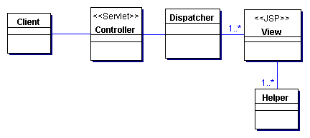
Figure 7.24 Dispatcher View class diagram

Participants and Responsibilities
Figure 7.25 shows the Dispatcher View sequence pattern.
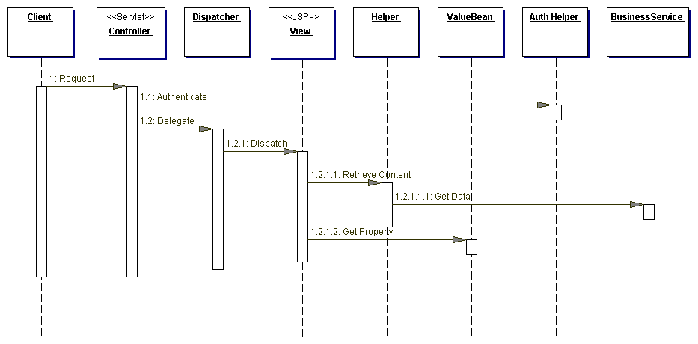
Figure 7.25 Dispatcher View sequence diagram
While the controller responsibilities are limited to system services, such as authentication and authorization, it is often still beneficial to centralize these aspects of the system. Notice also that, unlike in Service to Worker, the dispatcher does not make invocations on a business service in order to complete its view management processing.
The dispatcher functionality may be encapsulated in its own component. At the same time, when the responsibilities of the dispatcher are limited, as described by this pattern, the dispatcher functionality is often folded into another component, such as the controller or the view (see "Dispatcher in Controller Strategy" on page 183 and "Dispatcher in View Strategy" on page 32).
In fact, the dispatcher functionality may even be completed by the container, in the case where there is no extra application-level logic necessary. An example is a view called main.jsp that is given the alias name first. The container will process the following request, translate the alias name to the physical resource name, and dispatch directly to that resource:
http://some.server.com/first --> /mywebapp/main.jsp
In this case, we are left with the View Helper pattern, with the request being handled directly by the view. Since the view is the initial contact point for handling a request, custom tag helpers are typically used in these cases to perform business processing or to delegate this processing to other components. See the listing in Example 7.35 in the "Sample Code" section for an implementation sample.
Thus, the Dispatcher View pattern describes a continuum of related scenarios, moving from a scenario that is very structurally similar to Service to Worker to one that is similar to View Helper.

Controller
The controller is typically the initial contact point for handling a request. The controller manages authentication and authorization, and delegates to a dispatcher to do view management.

Dispatcher
A dispatcher is responsible for view management and navigation, managing the choice of the next view to present to the user and providing the mechanism for vectoring control to this resource.
A dispatcher can be encapsulated within a controller (see "Front Controller" on page 172) or can be a separate component working in coordination. The dispatcher can provide static dispatching to the view or may provide a more sophisticated dynamic dispatching mechanism.

View
A view represents and displays information to the client. The information that is used in a display is retrieved from a model. Helpers support views by encapsulating and adapting a model for use in a display.

Helper
A helper is responsible for helping a view or controller complete its processing. Thus, helpers have numerous responsibilities, including gathering data required by the view and storing this intermediate model, in which case the helper is sometimes referred to as a value bean. Additionally, helpers may adapt this data model for use by the view. Helpers can service requests for data from the view by simply providing access to the raw data or by formatting the data as Web content.
A view may work with any number of helpers, which are typically implemented as JavaBeans components (JSP 1.0+) and custom tags (JSP 1.1+). Additionally, a helper may represent a Command object or a Delegate (see "Business Delegate" on page 248).

ValueBean
A value bean is another name for a helper that is responsible for holding intermediate model state for use by a view. A typical case, as shown in the sequence diagram in Figure 7.12, has the business service returning a value bean in response to a request. In this case, ValueBean fulfills the role of a Transfer Object (see "Transfer Object" on page 261).

BusinessService
The business service is a role that is fulfilled by the service the client is seeking to access. Typically, the business service is accessed via a business delegate. The business delegate's role is to provide control and protection for the business service (see "Business Delegate" on page 248).

Strategies

Servlet Front Strategy
See "Servlet Front Strategy" on page 175.

JavaServer Pages Pages Front Strategy
See "JavaServer Pages (JSP) Pages Front Strategy" on page 178.

JSP View Strategy
See "JSP View Strategy" on page 190.

Servlet View Strategy
See "Servlet View Strategy" on page 191.

JavaBean Helper Strategy
See "JavaBean Helper Strategy" on page 194.

Custom Tag Helper Strategy
See "Custom Tag Helper Strategy" on page 194.

Dispatcher in Controller Strategy
See "Dispatcher in Controller Strategy" on page 183.
As stated, the Service to Worker and Dispatcher View patterns suggest a continuum, where behavior is encapsulated closer to the front in Service to Worker or moved farther back in Dispatcher View.
Figure 7.26 shows the interactions for this strategy.
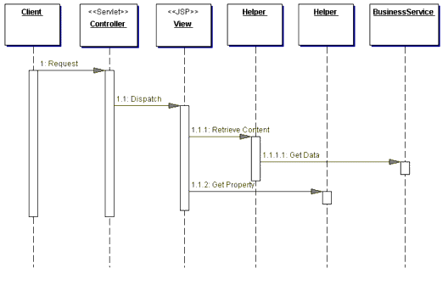
Figure 7.26 Dispatcher in Controller Strategy
The controller does not create an explicit dispatcher object. Instead, the controller takes care of dispatching to the view. Alternatively, one could implement a dispatcher to which the controller can delegate the dispatching function.

Dispatcher in View Strategy
If the controller is removed due to its limited role, the dispatcher may be moved into a view. This design can be useful in cases where there is typically one view that maps to a specific request, but where a secondary view may be used on an infrequent basis. For example, based on some information in the request or results of some processing in a view, a custom tag helper in the view might vector control to a secondary view. A typical case is when a client request is submitted to a specific view, and will be serviced by that view in almost every case. Consider the case where the user has not been authenticated, but requests access to one of the few protected JSP pages on a site. Since the site has only a few protected pages, and limited dynamic content, authentication can be performed within those JSP pages, instead of using a site-wide centralized controller. Those pages that need authentication include a custom tag helper at the top of the page. This helper performs the authentication check and either displays the page for the user or forwards the user to an authentication page.
Figure 7.27 represents this scenario.
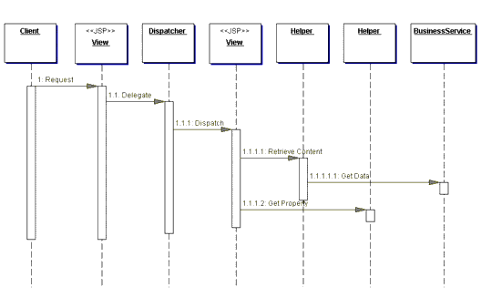Figure 7.27 Dispatcher in View Strategy

Transformer Helper Strategy
See "Transformer Helper Strategy" on page 200.

Consequences
- Centralizes Control and Improves Reuse and Maintainability
Control processing is handled in a central place for multiple requests. It is easier to manage these activities and perform dispatching from a centralized point, since a central access point means code is reused across multiple requests, reducing duplication and easing maintenance.
- Improves Application Partitioning
Use of helpers results in a cleaner separation of the view from an application's business processing. The helpers, in the form of JavaBeans components (JSP 1.0+) and Custom tags (JSP 1.1+), provide a place for business logic to be factored out of the JSP page, where scriptlet code quickly becomes cumbersome and unwieldy in large projects.
- Improves Role Separation
Separating the formatting logic from the application business logic also reduces dependencies that individuals fulfilling different roles might have on the same resources. For example, a software developer would own code that is embedded within HTML markup, while a Web production team member would need to modify page layout and design components that are intermingled with business logic. Because neither individual fulfilling these roles may be familiar with the implementation specifics of the other individual's work, there is the likelihood of inadvertent modifications introducing bugs into the system.

Sample Code
The following sample code shows an implementation of the Dispatcher View pattern, using a controller servlet and a view with JavaBean and custom tag helpers. The implementation includes the Servlet Front Strategy, Dispatcher in Controller Strategy, JSP View Strategy, and custom tag and JavaBean helper strategies. A very basic composite view is used as well. A screen shot of the resulting display is shown in Figure 7.28.
Example 7.34 shows the controller servlet, which simply completes an authentication check and passes control to the appropriate view. Notice that the controller does not directly delegate to any helper components in order to make invocations to the business tier via a Delegate. These responsibilities are deferred to the view, which is called accountdetails.jsp and can be seen in Example 7.35. The sample code uses a LogManager to log messages. These messages are displayed at the bottom of the output page, for the purposes of this example, and can be seen in the screen shots in Figure 7.23 and Figure 7.28.
Example 7.34 Dispatcher View Controller Servlet
public class Controller extends HttpServlet {
/** Processes requests for both HTTP
* <code>GET</code> and <code>POST</code> methods.
* @param request servlet request
* @param response servlet response
*/
protected void processRequest(HttpServletRequest
request, HttpServletResponse response)
throws ServletException, java.io.IOException {
String nextview;
try {
LogManager.recordStrategy(request, "Dispatcher View",
" Servlet Front Strategy; " + "JSP View Strategy; Custom tag helper Strategy");
LogManager.logMessage(request, getSignature(),
"Process incoming request. ");

// Use a helper object to gather parameter
// specific information.
RequestHelper helper = new
RequestHelper(request, response);
LogManager.logMessage(request,
getSignature(), " Authenticate user");

Authenticator auth = new BasicAuthenticator();
auth.authenticate(helper);

//This is an oversimplification for the sake of
// simplicity. Typically, there will be a
// mapping from logical name to resource name at
// this point
LogManager.logMessage(request, getSignature(),
"Getting nextview");
nextview = request.getParameter("nextview");

LogManager.logMessage(request, getSignature(),
"Dispatching to view: " + nextview);
}
catch (Exception e) {
LogManager.logMessage(
"Handle exception appropriately",
e.getMessage() );
/** ApplicationResources provides a simple API
* for retrieving constants and other
* preconfigured values**/
nextview = ApplicationResources.getInstance().
getErrorPage(e);
}
dispatch(request, response, nextview);
}

/** Handles the HTTP <code>GET</code> method.
* @param request servlet request
* @param response servlet response
*/
protected void doGet(HttpServletRequest request,
HttpServletResponse response)
throws ServletException, java.io.IOException {
processRequest(request, response);
}

/** Handles the HTTP <code>POST</code> method.
* @param request servlet request
* @param response servlet response
*/
protected void doPost(HttpServletRequest request,
HttpServletResponse response)
throws ServletException, java.io.IOException {
processRequest(request, response);
}

/** Returns a short description of the servlet. */
public String getServletInfo(){
return getSignature();
}

public void init(ServletConfig config) throws
ServletException {
super.init(config);
}

public void destroy() { }

/** dispatcher method
*/
protected void dispatch(HttpServletRequest request,
HttpServletResponse response, String page)
throws javax.servlet.ServletException,
java.io.IOException {
RequestDispatcher dispatcher =
getServletContext().
getRequestDispatcher(page);
dispatcher.forward(request, response);
}

private String getSignature() {
return "DispatcherView-Controller";
}
}

Notice that the view uses custom tag helpers to manage content retrieval, since this activity was not completed in the controller. When custom tags are used in this manner, they typically become thin facades for standalone components to which they delegate to complete this processing. This way, the general processing logic is loosely coupled to the tag implementation. If custom tags are not used with Dispatcher View, then too much scriptlet code typically ends up in the JSP page, a situation to be avoided.
Example 7.35 View - accountdetails.jsp
<%@ taglib uri="/web-INF/corepatternstaglibrary.tld"
prefix="corepatterns" %>

<html>
<head><title>AccountDetails</title></head>
<body>

<corepatterns:AccountQuery queryParams="custid,acctkey" scope="request" />

<h2><center> Account Detail for <corepatterns:Account
attribute="owner" /></h2> <br><br>

<tr>
<td>Account Number :</td>
<td><corepatterns:Account attribute="number" /></td>
</tr>

<tr>
<td>Account Type:</td>
<td><corepatterns:Account attribute="type" /></td>
</tr>

<tr>
<td>Account Balance:</td>
<td><corepatterns:Account attribute="balance" /></td>
</tr>

<tr>
<td>OverDraft Limit:</td>
<td><corepatterns:Account attribute="overdraftLimit" /></td>
</tr>
<table border=3>
</table>
</corepatterns:AccountQuery>
<br><br>
</center>
<%@ include file="/jsp/trace.jsp" %>
</body>
</html>
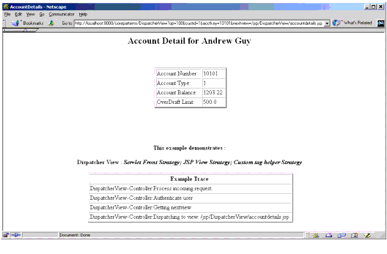
Figure 7.28 Dispatcher View sample screen shot

Related Patterns
- Front Controller
The Service to Worker pattern is the result of combining the View Helper pattern with a dispatcher in coordination with the Front Controller pattern.
- View Helper
The Service to Worker pattern is the result of combining the View Helper pattern with a dispatcher in coordination with the Front Controller pattern.
- Service to Worker
The Service to Worker pattern is another name for the combination of the Front Controller pattern with a dispatcher and the View Helper pattern. The Service to Worker and Dispatcher View patterns are identical with respect to the components involved, but differ in the division of labor among those components. The Dispatcher View pattern suggests deferring content retrieval to the time of view processing. Also, the dispatcher plays a more limited role in view management, as the choice of view is typically already included in the request.

Core J2EE Patterns - Service to Worker

Context
The system controls flow of execution and access to business data, from which it creates presentation content.
Note
The Service to Worker pattern, like the Dispatcher View pattern, describes a common combination of other patterns from the catalog. Both of these macro patterns describe the combination of a controller and dispatcher with views and helpers. While describing this common structure, they emphasize related but different usage patterns.

Problem
The problem is a combination of the problems solved by the Front Controller and View Helper patterns in the presentation tier. There is no centralized component for managing access control, content retrieval, or view management, and there is duplicate control code scattered throughout various views. Additionally, business logic and presentation formatting logic are intermingled within these views, making the system less flexible, less reusable, and generally less resilient to change.
Intermingling business logic with view processing also reduces modularity and provides a poor separation of roles among Web production and software development teams.

Forces
- Authentication and authorization checks are completed per request.
- Scriptlet code within views should be minimized.
- Business logic should be encapsulated in components other than the view.
- Control flow is relatively complex and based on values from dynamic content.
- View management logic is relatively sophisticated, with multiple views potentially mapping to the same request.

Solution
Combine a controller and dispatcher with views and helpers (see "Front Controller" on page 172 and "View Helper" on page 186) to handle client requests and prepare a dynamic presentation as the response. Controllers delegate content retrieval to helpers, which manage the population of the intermediate model for the view. A dispatcher is responsible for view management and navigation and can be encapsulated either within a controller or a separate component.
Service to Worker describes the combination of the Front Controller and View Helper patterns with a dispatcher component.
While this pattern and the Dispatcher View pattern describe a similar structure, the two patterns suggest a different division of labor among the components. In Service to Worker, the controller and the dispatcher have more responsibilities.
Since the Service to Worker and Dispatcher View patterns represent a common combination of other patterns from the catalog, each warrants its own name to promote efficient communication among developers. Unlike the Service to Worker pattern, the Dispatcher View pattern suggests deferring content retrieval to the time of view processing.
In the Dispatcher View pattern, the dispatcher typically plays a limited to moderate role in view management. In the Service to Worker pattern, the dispatcher typically plays a moderate to large role in view management.
A limited role for the dispatcher occurs when no outside resources are utilized in order to choose the view. The information encapsulated in the request is sufficient to determine the view to dispatch the request. For example,
http://some.server.com/servlet/Controller?next=login.jsp
The sole responsibility of the dispatcher component in this case is to dispatch to the view login.jsp.
An example of the dispatcher playing a moderate role is the case where the client submits a request directly to a controller with a query parameter that describes an action to be completed:
http://some.server.com/servlet/Controller?action=login
The responsibility of the dispatcher component here is to translate the logical name login into the resource name of an appropriate view, such as login.jsp, and dispatch to that view. To accomplish this translation, the dispatcher may access resources such as an XML configuration file that specifies the appropriate view to display.
On the other hand, in the Service to Worker pattern, the dispatcher might be more sophisticated. The dispatcher may invoke a business service to determine the appropriate view to display.
The shared structure of Service to Worker and Dispatcher View consists of a controller working with a dispatcher, views, and helpers.

Structure
The class diagram in Figure 7.20 represents the Service to Worker pattern.
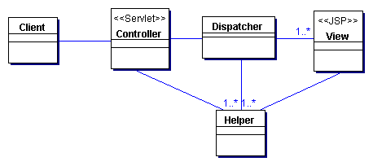
Figure 7.20 Service to Worker class diagram

Participants and Responsibilities
Figure 7.21 shows the sequence diagram that represents the Service to Worker pattern.
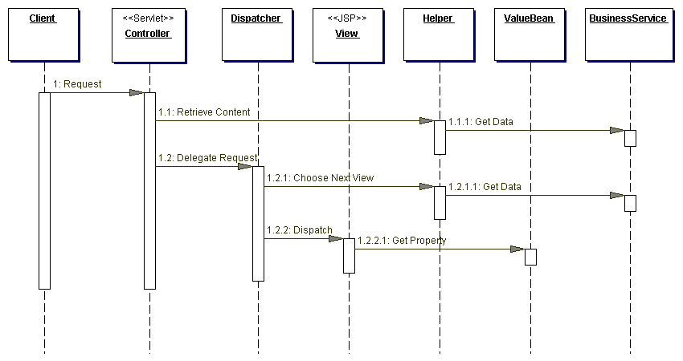
Figure 7.21 Service to Worker sequence diagram
As stated, Service to Worker and Dispatcher View represent a similar structure. The main difference is that Service to Worker describes architectures with more behavior "up front" in the controller and dispatcher, while Dispatcher View describes architectures with more behavior moved back to the time of view processing. Thus, the two patterns suggest a continuum, where behavior is either encapsulated closer to the front or moved farther back in the process flow.

Controller
The controller is typically the initial contact point for handling a request. It works with a dispatcher to complete view management and navigation. The controller manages authentication, authorization, content retrieval, validation, and other aspects of request handling. It delegates to helpers to complete portions of this work.

Dispatcher
A dispatcher is responsible for view management and navigation, managing the choice of the next view to present to the user and providing the mechanism for vectoring control to this resource.
A dispatcher can be encapsulated within a controller (see "Front Controller" on page 172) or it can be a separate component working in coordination with the controller. The dispatcher can provide static dispatching to the view or it may provide a more sophisticated dynamic dispatching mechanism.
The dispatcher uses the RequestDispatcher object (supported in the servlet specification), but it also typically encapsulates some additional processing. The more responsibilities that this component encapsulates, the more it fits into the Service to Worker pattern. Conversely, when the dispatcher plays a more limited role, it fits more closely into the Dispatcher View pattern.

View
A View represents and displays information to the client. The information that is used in a display is retrieved from a model. Helpers support views by encapsulating and adapting a model for use in a display.

Helper
A helper is responsible for helping a view or controller complete its processing. Thus, helpers have numerous responsibilities, including gathering data required by the view and storing this intermediate model, in which case the helper is sometimes referred to as a value bean. Additionally, helpers may adapt this data model for use by the view. Helpers can service requests for data from the view by simply providing access to the raw data or by formatting the data as Web content.
A view may work with any number of helpers, which are typically implemented as JavaBeans (JSP 1.0+) components and custom tags (JSP 1.1+). Additionally, a helper may represent a Command object or a delegate (see "Business Delegate" on page 248).

ValueBean
A value bean is another name for a helper that is responsible for holding intermediate model state for use by a view. A typical case, as shown in the sequence diagram in Figure 7.12, has the business service returning a value bean in response to a request. In this case, ValueBean fulfills the role of a Transfer Object (see "Transfer Object" on page 261).

BusinessService
The business service is a role that is fulfilled by the service the client is seeking to access. Typically, the business service is accessed via a Business delegate. The business delegate's role is to provide control and protection for the business service (see the "Business Delegate" on page 248).

Strategies

Servlet Front Strategy
See "Servlet Front Strategy" on page 175.

JavaServer Pages Front Strategy
See "JSP Front Strategy" on page 178.

JSP View Strategy
See "JSP View Strategy" on page 190.

Servlet View Strategy
See "Servlet View Strategy" on page 191.

JavaBean Helper Strategy
See "JavaBean Helper Strategy" on page 194.

Custom Tag Helper Strategy
See "Custom Tag Helper Strategy" on page 194.

Dispatcher in Controller Strategy
See "Dispatcher in Controller Strategy" on page 183.
As stated, the Service to Worker and Dispatcher View patterns suggest a continuum, where behavior is encapsulated closer to the front or moved farther back in the process flow. Figure 7.22 describes a scenario in which the controller is heavily loaded with upfront work, but the dispatcher functionality is minimal.
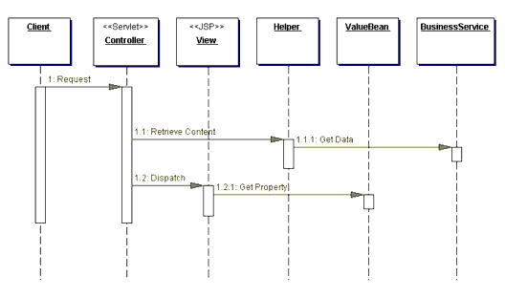
Figure 7.22 Folding the dispatcher into the controller

Transformer Helper Strategy
See "Transformer Helper Strategy" on page 200.

Consequences
- Centralizes Control and Improves Modularity and Reuse
This pattern suggests providing a central place to handle system services and business logic across multiple requests. The controller manages business logic processing and request handling. Keep in mind, though, that as control centralizes, it is possible to introduce a single point of failure.
The pattern also promotes cleaner application partitioning and encourages reuse. Common code is moved into a controller and reused per request and moved into helper components, to which controllers and views delegate. The improved modularity and reuse means less duplication, which typically means a more bug-free environment.
- Improves Application Partitioning
Using helpers results in a cleaner separation of the view from the business processing in an application. Helpers, in the form of JavaBeans (JSP 1.0+) and Custom tags (JSP 1.1+), provide a place for business logic to be factored out of the JSP page. If the business logic is left in a JSP page, large projects result in cumbersome and unwieldy scriptlet code.
- Improves Role Separation
Separating the formatting logic from the application business logic also reduces dependencies on the same resources among individuals fulfilling different roles. Without this separation, for example, a software developer would own code that is embedded within HTML markup, while a Web production team member would need to modify page layout and design components that are intermingled with business logic. Because neither individual fulfilling these roles is familiar with the implementation specifics of the other individual's work, it raises the likelihood of modifications accidentally introducing bugs into the system.

Sample Code
The following sample code shows an implementation of the Service to Worker pattern, using a controller servlet, a command helper, a dispatcher component, and a view. The implementation includes the Servlet Front Strategy, Command and Controller Strategy, JSP View Strategy, and JavaBean Helper Strategy. A very basic composite view is used as well. A screen shot of the resulting display is shown in Figure 7.23.
Example 7.29 shows the controller servlet, which delegates to a Command object (Command and Controller Strategy) to complete the control processing. The Command object is retrieved via a factory invocation, which returns the generic Command type, an interface shown in Example 7.30. The sample code uses a LogManager to log messages. The screen shots in Figure 7.23 and Figure 7.28 show these messages displayed at the bottom of the page, for the purposes of this example.
Example 7.29 Controller Servlet with Command and Controller Strategy
public class Controller extends HttpServlet {
/** Processes requests for both HTTP
* <code>GET</code> and <code>POST</code> methods.
* @param request servlet request
* @param response servlet response
*/
protected void processRequest(HttpServletRequest
request, HttpServletResponse response)
throws ServletException, java.io.IOException {
String next;

try {
// Log pattern info
LogManager.recordStrategy(request,
"Service To Worker",
" ServletFront Strategy;" +
" JSPView Strategy; JavaBean helper Strategy");

LogManager.logMessage(request, getSignature(),
"Process incoming request. ");

// Use a helper object to gather parameter
// specific information.
RequestHelper helper = new RequestHelper(request, response);

LogManager.logMessage(request, getSignature(),
"Getting command object helper");

// Get command object helper
Command command = helper.getCommand();
// delegate processing to the command object,
// passing request and response objects along
next = command.execute(helper);

/** If the above command returns a value, we
* will dispatch from the controller. In this
* example, though, the command will use a
* separate dispatcher component to choose a
* view and dispatch to that view. The command
* object delegates to this dispatcher
* component in its execute method, above, and
* control should not return to this point **/
}
catch (Exception e) {
LogManager.logMessage( "EmployeeController(CommandStrategy)",
e.getMessage() );

/** ApplicationResources provides a simple API
* for retrieving constants and other
* preconfigured values**/
next = ApplicationResources.getInstance().getErrorPage(e);
}

dispatch(request, response, next);

}

/** Handles the HTTP <code>GET</code> method.
* @param request servlet request
* @param response servlet response
*/
protected void doGet(HttpServletRequest request,
HttpServletResponse response)
throws ServletException, java.io.IOException {
processRequest(request, response);
}

/** Handles the HTTP <code>POST</code> method.
* @param request servlet request
* @param response servlet response
*/
protected void doPost(HttpServletRequest request,
HttpServletResponse response)
throws ServletException, java.io.IOException {
processRequest(request, response);
}

/** Returns a short description of the servlet. */
public String getServletInfo() {
return getSignature();
}

/** dispatcher method */
protected void dispatch(HttpServletRequest request,
HttpServletResponse response,
String page) throws
javax.servlet.ServletException,
java.io.IOException {
RequestDispatcher dispatcher =
getServletContext().getRequestDispatcher(page);
dispatcher.forward(request, response);
}

public void init(ServletConfig config) throws
ServletException {
super.init(config);
}

public void destroy() { }

private String getSignature() {
return "ServiceToWorker-Controller";
}
}
Example 7.30 Command Interface
public interface Command {
public String execute(RequestHelper helper) throws
javax.servlet.ServletException, java.io.IOException;
}
Each Command Object helper implements this generic interface, which is an example of the GoF Command pattern. The Command object is an instance of the ViewAccountDetails class, which is shown in Example 7.31. The command instance delegates to an AccountingAdapter to make an invocation to the business tier via business delegate. The adapter class is shown in Example 7.32. It uses a separate dispatcher component to determine the next view to which control should be dispatched and to actually dispatch to this view.
Example 7.30 Command Interface
public interface Command {
public String execute(RequestHelper helper) throws
javax.servlet.ServletException, java.io.IOException;
}
Example 7.31 ViewAccountDetailsCommand
public class ViewAccountDetailsCommand implements
Command {
public ViewAccountDetailsCommand() { }

// view account details operation
public String execute(RequestHelper helper)
throws javax.servlet.ServletException,
java.io.IOException {
/** This will tell the user that a system error
* has occured and will typically not be seen. It
* should be stored in a resource file **/
String systemerror = "/jspdefaultprocessingerror.jsp";

LogManager.logMessage(helper.getRequest(),
"ViewAccountDetailsCommand",
"Get Account Details from an adapter object");

/** Use an adapter to retrieve data from business
* service, and store it in a request attribute.
* Note: Object creation could be avoided via
* factory, but for example purposes object
* instantiation is shown **/
AccountingAdapter adapter = new AccountingAdapter();
adapter.setAccountInfo(helper);

LogManager.logMessage(helper.getRequest(),
"ViewAccountDetailsCommand", "processing complete");

/** Note: Object creation could be avoided via
* factory, but for example purposes object
* instantiation is shown**/
Dispatcher dispatcher = new Dispatcher();
dispatcher.dispatch(helper);

/** This return string will not be sent in a
* normal execution of this scenario, because
* control is forwarded to another resource
* before reaching this point. Some commands do
* return a String, though, so the return value
* is included for correctness. **/
return systemerror;
}
}
Example 7.32 AccountingAdapter
public class AccountingAdapter {
public void setAccountInfo(
RequestHelper requestHelper) {
LogManager.logMessage(
requestHelper.getRequest(),
"Retrieving data from business tier");

// retrieve data from business tier via
// delegate. Omit try/catch block for brevity.
AccountDelegate delegate = new AccountDelegate();
AccountTO account =
delegate.getAccount(
requestHelper.getCustomerId(),
requestHelper.getAccountKey());

LogManager.logMessage(
requestHelper.getRequest(),
"Store account Transfer Object in request attribute");

// transport data using request object
requestHelper.getRequest().setAttribute(
"account", account);
}
}

The invocation on the business service via the delegate yields an Account Transfer Object, which the adapter stores in a request attribute for use by the view. Example 7.33 shows accountdetails.jsp, the JSP page to which the request is dispatched. The Transfer Object is imported via the standard <jsp:useBean> tag and its properties accessed with the standard <jsp:getProperty> tag. Also, the view uses a very simple composite strategy, doing a translation-time inclusion of the trace.jsp subview, which is responsible for displaying log information on the display solely for example purposes.
Example 7.33 View - accountdetails.jsp
<html>
<head><title>AccountDetails</title></head>
<body>

<jsp:useBean id="account" scope="request"
class="corepatterns.util.AccountTO" />

<h2><center> Account Detail for <jsp:getProperty
name="account" property="owner" />
</h2> <br><br>
<table border=3>
<tr>
<td>Account Number :</td>
<td><jsp:getProperty name "account" property="number" /></td>
</tr>

<tr>
<td>Account Type:</td>
<td><jsp:getProperty name="account" property="type" /></td>
</tr>

<tr>
<td>Account Balance:</td>
<td><jsp:getProperty name="account" property="balance" /></td>
</tr>

<tr>
<td>OverDraft Limit:</td>
<td><jsp:getProperty name="account" property="overdraftLimit"/></td>
</tr>

</table>
<br><br>
</center>
<%@ include file="/jsp/trace.jsp" %>
</body>
</html>
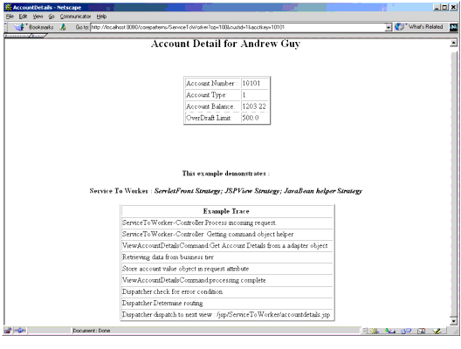
Figure 7.23 Service to Worker sample screen shot

Related Patterns
- Front Controller and View Helper
The Service to Worker pattern is the result of combining the View Helper pattern with a dispatcher, in coordination with the Front Controller pattern.
- Dispatcher View
The Dispatcher View pattern is another name for the combination of the Front Controller pattern with a dispatcher, and the View Helper pattern. The Service to Worker and the Dispatcher View patterns are identical with respect to the components involved, but differ in the division of labor among those components. The Dispatcher View pattern suggests deferring content retrieval to the time of view processing. Also, the dispatcher plays a more limited role in view management, as the choice of view is typically already included in the request.

Core J2EE Patterns - Business Delegate

Context
A multi-tiered, distributed system requires remote method invocations to send and receive data across tiers. Clients are exposed to the complexity of dealing with distributed components.

Problem
Presentation-tier components interact directly with business services. This direct interaction exposes the underlying implementation details of the business service application program interface (API) to the presentation tier. As a result, the presentation-tier components are vulnerable to changes in the implementation of the business services: When the implementation of the business services change, the exposed implementation code in the presentation tier must change too.
Additionally, there may be a detrimental impact on network performance because presentation-tier components that use the business service API make too many invocations over the network. This happens when presentation-tier components use the underlying API directly, with no client-side caching mechanism or aggregating service.
Lastly, exposing the service APIs directly to the client forces the client to deal with the networking issues associated with the distributed nature of Enterprise JavaBeans (EJB) technology.

Forces
- Presentation-tier clients need access to business services.
- Different clients, such as devices, Web clients, and thick clients, need access to business service.
- Business services APIs may change as business requirements evolve.
- It is desirable to minimize coupling between presentation-tier clients and the business service, thus hiding the underlying implementation details of the service, such as lookup and access.
- Clients may need to implement caching mechanisms for business service information.
- It is desirable to reduce network traffic between client and business services.

Solution
Use a Business Delegate to reduce coupling between presentation-tier clients and business services. The Business Delegate hides the underlying implementation details of the business service, such as lookup and access details of the EJB architecture.
The Business Delegate acts as a client-side business abstraction; it provides an abstraction for, and thus hides, the implementation of the business services. Using a Business Delegate reduces the coupling between presentation-tier clients and the system's business services. Depending on the implementation strategy, the Business Delegate may shield clients from possible volatility in the implementation of the business service API. Potentially, this reduces the number of changes that must be made to the presentation-tier client code when the business service API or its underlying implementation changes.
However, interface methods in the Business Delegate may still require modification if the underlying business service API changes. Admittedly, though, it is more likely that changes will be made to the business service rather than to the Business Delegate.
Often, developers are skeptical when a design goal such as abstracting the business layer causes additional upfront work in return for future gains. However, using this pattern or its strategies results in only a small amount of additional upfront work and provides considerable benefits. The main benefit is hiding the details of the underlying service. For example, the client can become transparent to naming and lookup services. The Business Delegate also handles the exceptions from the business services, such as java.rmi.Remote exceptions, Java Messages Service (JMS) exceptions and so on. The Business Delegate may intercept such service level exceptions and generate application level exceptions instead. Application level exceptions are easier to handle by the clients, and may be user friendly. The Business Delegate may also transparently perform any retry or recovery operations necessary in the event of a service failure without exposing the client to the problem until it is determined that the problem is not resolvable. These gains present a compelling reason to use the pattern.
Another benefit is that the delegate may cache results and references to remote business services. Caching can significantly improve performance, because it limits unnecessary and potentially costly round trips over the network.
A Business Delegate uses a component called the Lookup Service. The Lookup Service is responsible for hiding the underlying implementation details of the business service lookup code. The Lookup Service may be written as part of the Delegate, but we recommend that it be implemented as a separate component, as outlined in the Service Locator pattern (See "Service Locator" on page 368.)
When the Business Delegate is used with a Session Facade, typically there is a one-to-one relationship between the two. This one-to-one relationship exists because logic that might have been encapsulated in a Business Delegate relating to its interaction with multiple business services (creating a one-to-many relationship) will often be factored back into a Session Facade.
Finally, it should be noted that this pattern could be used to reduce coupling between other tiers, not simply the presentation and the business tiers.

Structure
Figure 8.1 shows the class diagram representing the Business Delegate pattern. The client requests the BusinessDelegate to provide access to the underlying business service. The BusinessDelegate uses a LookupService to locate the required BusinessService component.
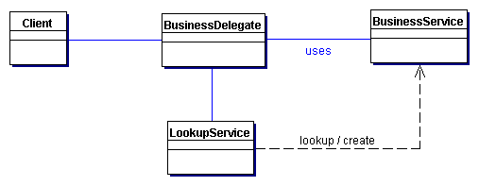
Figure 8.1 BusinessDelegate class diagram

Participants and Responsibilities
Figure 8.2 and Figure 8.3 show sequence diagrams that illustrate typical interactions for the Business Delegate pattern.
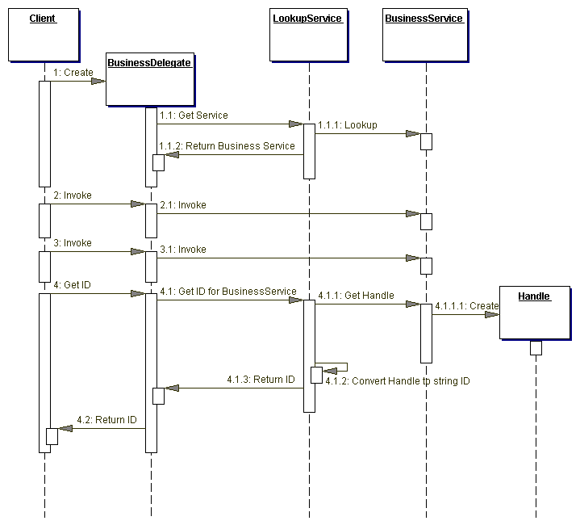
Figure 8.2 BusinessDelegate sequence diagram
The BusinessDelegate uses a LookupService for locating the business service. The business service is used to invoke the business methods on behalf of the client. The Get ID method shows that the BusinessDelegate can obtain a String version of the handle (such as EJBHandle object) for the business service and return it to the client as a String. The client can use the String version of the handle at a later time to reconnect to the business service it was using when it obtained the handle. This technique will avoid new lookups, since the handle is capable of reconnecting to its business service instance. It should be noted that handle objects are implemented by the container provider and may not be portable across containers from different vendors.
The sequence diagram in Figure 8.3 shows obtaining a BusinessService (such as a session or an entity bean) using its handle.
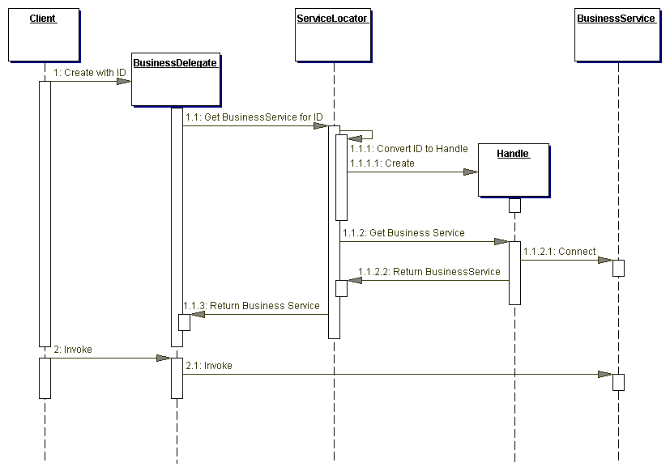
Figure 8.3 BusinessDelegate with ID sequence diagram

BusinessDelegate
The BusinessDelegate's role is to provide control and protection for the business service. The BusinessDelegate can expose two types of constructors to clients. One type of request instantiates the BusinessDelegate without an ID, while the other instantiates it with an ID, where ID is a String version of the reference to a remote object, such as EJBHome or EJBObject.
When initialized without an ID, the BusinessDelegate requests the service from the Lookup Service, typically implemented as a Service Locator (see "Service Locator" on page 368), which returns the Service Factory, such as EJBHome. The BusinessDelegate requests that the Service Factory locate, create, or remove a BusinessService, such as an enterprise bean.
When initialized with an ID string, the BusinessDelegate uses the ID string to reconnect to the BusinessService. Thus, the BusinessDelegate shields the client from the underlying implementation details of BusinessService naming and lookup. Furthermore, the presentation-tier client never directly makes a remote invocation on a BusinessSession; instead, the client uses the BusinessDelegate.

LookupService
The BusinessDelegate uses the LookupService to locate the BusinessService. The LookupService encapsulates the implementation details of BusinessService lookup.

BusinessService
The BusinessService is a business-tier component, such as an enterprise bean or a JMS component, that provides the required service to the client.

Strategies

Delegate Proxy Strategy
The Business Delegate exposes an interface that provides clients access to the underlying methods of the business service API. In this strategy, a Business Delegate provides proxy function to pass the client methods to the session bean it is encapsulating. The Business Delegate may additionally cache any necessary data, including the remote references to the session bean's home or remote objects to improve performance by reducing the number of lookups. The Business Delegate may also convert such references to String versions (IDs) and vice versa, using the services of a Service Locator.
The example implementation for this strategy is discussed in the "Sample Code" section of this pattern.

Delegate Adapter Strategy
The Business Delegate proves to be a nice fit in a B2B environment when communicating with Java 2 Platform, Enterprise Edition (J2EE) based services. Disparate systems may use an XML as the integration language. Integrating one system to another typically requires an Adapter [GoF] to meld the two disparate systems. Figure 8.4 gives an example.
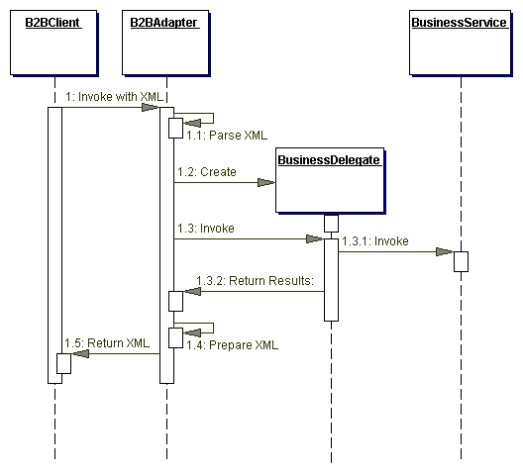
Figure 8.4 Using the Business Delegate pattern with an Adapter strategy

Consequences
- Reduces Coupling, Improves Manageability
The Business Delegate reduces coupling between the presentation tier and the business tier by hiding all business-tier implementation details. It is easier to manage changes because they are centralized in one place, the Business Delegate.
- Translates Business Service Exceptions
The Business Delegate is responsible for translating any network or infrastructure-related exceptions into business exceptions, shielding clients from knowledge of the underlying implementation specifics.
- Implements Failure Recovery and Thread Synchronization
The Business Delegate on encountering a business service failure, may implement automatic recovery features without exposing the problem to the client. If the recovery succeeds, the client need not know about the failure. If the recovery attempt does not succeed, then the Business Delegate needs to inform the client of the failure. Additionally, the business delegate methods may be synchronized, if necessary.
- Exposes Simpler, Uniform Interface to Business Tier
The Business Delegate, to better serve its clients, may provide a variant of the interface provided by the underlying enterprise beans.
- Impacts Performance
The Business Delegate may provide caching services (and better performance) to the presentation tier for common service requests.
- Introduces Additional Layer
The Business Delegate may be seen as adding an unnecessary layer between the client and the service, thus introducing added complexity and decreasing flexibility. Some developers may feel that it is an extra effort to develop Business Delegates with implementations that use the Delegate Proxy strategy. At the same time, the benefits of the pattern typically outweigh such drawbacks.
- Hides Remoteness
While location transparency is one of the benefits of this pattern, a different problem may arise due to the developer treating a remote service as if it was a local one. This may happen if the client developer does not understand that the Business Delegate is a client side proxy to a remote service. Typically, a method invocations on the Business Delegate results in a remote method invocation under the wraps. Ignoring this, the developer may tend to make numerous method invocations to perform a single task, thus increasing the network traffic.

Sample Code

Implementing the Business Delegate Pattern
Consider a Professional Services Application (PSA), where a Web-tier client needs to access a session bean that implements the Session Facade pattern. The Business Delegate pattern can be applied to design a Delegate class ResourceDelegate, which encapsulates the complexity of dealing with the session bean ResourceSession. The ResourceDelegate implementation for this example is shown in Example 8.1, and the corresponding remote interface for the Session Facade bean ResourceSession is shown in Example 8.2.
Example 8.1 Implementing Business Delegate Pattern - ResourceDelegate
// imports
...

public class ResourceDelegate {

// Remote reference for Session Facade
private ResourceSession session;

// Class for Session Facade's Home object
private static final Class homeClazz =
corepatterns.apps.psa.ejb.ResourceSessionHome.class;

// Default Constructor. Looks up home and connects
// to session by creating a new one
public ResourceDelegate() throws ResourceException {
try {
ResourceSessionHome home = (ResourceSessionHome)
ServiceLocator.getInstance().getHome(
"Resource", homeClazz);
session = home.create();
} catch(ServiceLocatorException ex) {
// Translate Service Locator exception into
// application exception
throw new ResourceException(...);
} catch(CreateException ex) {
// Translate the Session create exception into
// application exception
throw new ResourceException(...);
} catch(RemoteException ex) {
// Translate the Remote exception into
// application exception
throw new ResourceException(...);
}
}

// Constructor that accepts an ID (Handle id) and
// reconnects to the prior session bean instead
// of creating a new one
public BusinessDelegate(String id)
throws ResourceException {
super();
reconnect(id);
}

// Returns a String ID the client can use at a
// later time to reconnect to the session bean
public String getID() {
try {
return ServiceLocator.getId(session);
} catch (Exception e) {
// Throw an application exception
}
}

// method to reconnect using String ID
public void reconnect(String id)
throws ResourceException {
try {
session = (ResourceSession)
ServiceLocator.getService(id);
} catch (RemoteException ex) {
// Translate the Remote exception into
// application exception
throw new ResourceException(...);
}
}

// The following are the business methods
// proxied to the Session Facade. If any service
// exception is encountered, these methods convert
// them into application exceptions such as
// ResourceException, SkillSetException, and so
// forth.

public ResourceTO setCurrentResource(
String resourceId)
throws ResourceException {
try {
return session.setCurrentResource(resourceId);
} catch (RemoteException ex) {
// Translate the service exception into
// application exception
throw new ResourceException(...);
}
}

public ResourceTO getResourceDetails()
throws ResourceException {

try {
return session.getResourceDetails();
} catch(RemoteException ex) {
// Translate the service exception into
// application exception
throw new ResourceException(...);
}
}

public void setResourceDetails(ResourceTO vo)
throws ResourceException {
try {
session.setResourceDetails(vo);
} catch(RemoteException ex) {
throw new ResourceException(...);
}
}

public void addNewResource(ResourceTO vo)
throws ResourceException {
try {
session.addResource(vo);
} catch(RemoteException ex) {
throw new ResourceException(...);
}
}

// all other proxy method to session bean
...
}

Example 8.2 Remote Interface for ResourceSession
// imports
...
public interface ResourceSession extends EJBObject {

public ResourceTO setCurrentResource(
String resourceId) throws
RemoteException, ResourceException;

public ResourceTO getResourceDetails()
throws RemoteException, ResourceException;
public void setResourceDetails(ResourceTO resource)
throws RemoteException, ResourceException;

public void addResource(ResourceTO resource)
throws RemoteException, ResourceException;

public void removeResource()
throws RemoteException, ResourceException;

// methods for managing blockout time by the
// resource
public void addBlockoutTime(Collection blockoutTime)
throws RemoteException, BlockoutTimeException;

public void updateBlockoutTime(
Collection blockoutTime)
throws RemoteException, BlockoutTimeException;

public void removeBlockoutTime(
Collection blockoutTime)
throws RemoteException, BlockoutTimeException;

public void removeAllBlockoutTime()
throws RemoteException, BlockoutTimeException;

// methods for resource skillsets time by the
//resource
public void addSkillSets(Collection skillSet)
throws RemoteException, SkillSetException;

public void updateSkillSets(Collection skillSet)
throws RemoteException, SkillSetException;

public void removeSkillSet(Collection skillSet)
throws RemoteException, SkillSetException;

...
}

Related Patterns
- Service Locator
The Service Locator pattern may be used to create the Business Delegate's Service Locator, hiding the implementation details of any business service lookup and access code.
- Proxy [GoF]
A Business Delegate may act as a proxy, providing a stand-in for objects in the business tier.
- Adapter [GoF]
A Business Delegate may use the Adapter pattern to provide coupling for disparate systems.
- Broker [POSA1]
A Business Delegate performs the role of a broker to decouple the business tier objects from the clients in other tiers.

Core J2EE Patterns - Data Access Object

Context
Access to data varies depending on the source of the data. Access to persistent storage, such as to a database, varies greatly depending on the type of storage (relational databases, object-oriented databases, flat files, and so forth) and the vendor implementation.

Problem
Many real-world Java 2 Platform, Enterprise Edition (J2EE) applications need to use persistent data at some point. For many applications, persistent storage is implemented with different mechanisms, and there are marked differences in the APIs used to access these different persistent storage mechanisms. Other applications may need to access data that resides on separate systems. For example, the data may reside in mainframe systems, Lightweight Directory Access Protocol (LDAP) repositories, and so forth. Another example is where data is provided by services through external systems such as business-to-business (B2B) integration systems, credit card bureau service, and so forth.
Typically, applications use shared distributed components such as entity beans to represent persistent data. An application is considered to employ bean-managed persistence (BMP) for its entity beans when these entity beans explicitly access the persistent storage-the entity bean includes code to directly access the persistent storage. An application with simpler requirements may forego using entity beans and instead use session beans or servlets to directly access the persistent storage to retrieve and modify the data. Or, the application could use entity beans with container-managed persistence, and thus let the container handle the transaction and persistent details.
Applications can use the JDBC API to access data residing in a relational database management system (RDBMS). The JDBC API enables standard access and manipulation of data in persistent storage, such as a relational database. The JDBC API enables J2EE applications to use SQL statements, which are the standard means for accessing RDBMS tables. However, even within an RDBMS environment, the actual syntax and format of the SQL statements may vary depending on the particular database product.
There is even greater variation with different types of persistent storage. Access mechanisms, supported APIs, and features vary between different types of persistent stores such as RDBMS, object-oriented databases, flat files, and so forth. Applications that need to access data from a legacy or disparate system (such as a mainframe, or B2B service) are often required to use APIs that may be proprietary. Such disparate data sources offer challenges to the application and can potentially create a direct dependency between application code and data access code. When business components-entity beans, session beans, and even presentation components like servlets and helper objects for JavaServer Pages (JSP) pages --need to access a data source, they can use the appropriate API to achieve connectivity and manipulate the data source. But including the connectivity and data access code within these components introduces a tight coupling between the components and the data source implementation. Such code dependencies in components make it difficult and tedious to migrate the application from one type of data source to another. When the data source changes, the components need to be changed to handle the new type of data source.

Forces
- Components such as bean-managed entity beans, session beans, servlets, and other objects like helpers for JSP pages need to retrieve and store information from persistent stores and other data sources like legacy systems, B2B, LDAP, and so forth.
- Persistent storage APIs vary depending on the product vendor. Other data sources may have APIs that are nonstandard and/or proprietary. These APIs and their capabilities also vary depending on the type of storage-RDBMS, object-oriented database management system (OODBMS), XML documents, flat files, and so forth. There is a lack of uniform APIs to address the requirements to access such disparate systems.
- Components typically use proprietary APIs to access external and/or legacy systems to retrieve and store data.
- Portability of the components is directly affected when specific access mechanisms and APIs are included in the components.
- Components need to be transparent to the actual persistent store or data source implementation to provide easy migration to different vendor products, different storage types, and different data source types.

Solution
Use a Data Access Object (DAO) to abstract and encapsulate all access to the data source. The DAO manages the connection with the data source to obtain and store data.
The DAO implements the access mechanism required to work with the data source. The data source could be a persistent store like an RDBMS, an external service like a B2B exchange, a repository like an LDAP database, or a business service accessed via CORBA Internet Inter-ORB Protocol (IIOP) or low-level sockets. The business component that relies on the DAO uses the simpler interface exposed by the DAO for its clients. The DAO completely hides the data source implementation details from its clients. Because the interface exposed by the DAO to clients does not change when the underlying data source implementation changes, this pattern allows the DAO to adapt to different storage schemes without affecting its clients or business components. Essentially, the DAO acts as an adapter between the component and the data source.

Structure
Figure 9.1 shows the class diagram representing the relationships for the DAO pattern.
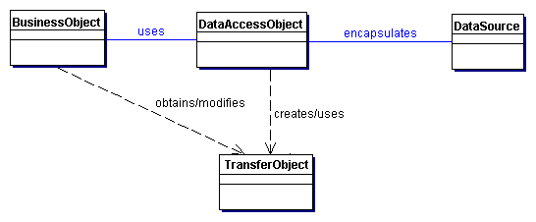
Figure 9.1 Data Access Object

Participants and Responsibilities
Figure 9.2 contains the sequence diagram that shows the interaction between the various participants in this pattern.
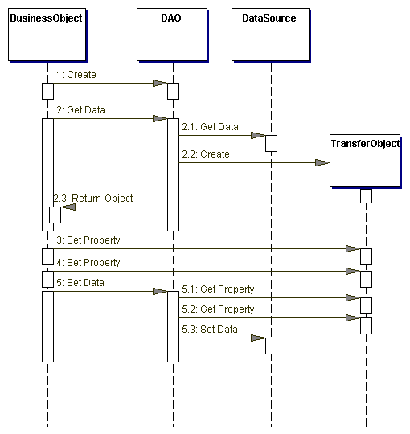
Figure 9.2 Data Access Object sequence diagram

BusinessObject
The BusinessObject represents the data client. It is the object that requires access to the data source to obtain and store data. A BusinessObject may be implemented as a session bean, entity bean, or some other Java object, in addition to a servlet or helper bean that accesses the data source.

DataAccessObject
The DataAccessObject is the primary object of this pattern. The DataAccessObject abstracts the underlying data access implementation for the BusinessObject to enable transparent access to the data source. The BusinessObject also delegates data load and store operations to the DataAccessObject.

DataSource
This represents a data source implementation. A data source could be a database such as an RDBMS, OODBMS, XML repository, flat file system, and so forth. A data source can also be another system (legacy/mainframe), service (B2B service or credit card bureau), or some kind of repository (LDAP).

TransferObject
This represents a Transfer Object used as a data carrier. The DataAccessObject may use a Transfer Object to return data to the client. The DataAccessObject may also receive the data from the client in a Transfer Object to update the data in the data source.

Strategies

Automatic DAO Code Generation Strategy
Since each BusinessObject corresponds to a specific DAO, it is possible to establish relationships between the BusinessObject, DAO, and underlying implementations (such as the tables in an RDBMS). Once the relationships are established, it is possible to write a simple application-specific code-generation utility that generates the code for all DAOs required by the application. The metadata to generate the DAO can come from a developer-defined descriptor file. Alternatively, the code generator can automatically introspect the database and provide the necessary DAOs to access the database. If the requirements for DAOs are sufficiently complex, consider using third-party tools that provide object-to-relational mapping for RDBMS databases. These tools typically include GUI tools to map the business objects to the persistent storage objects and thereby define the intermediary DAOs. The tools automatically generate the code once the mapping is complete, and may provide other value-added features such as results caching, query caching, integration with application servers, integration with other third-party products (e.g., distributed caching), and so forth.

Factory for Data Access Objects Strategy
The DAO pattern can be made highly flexible by adopting the Abstract Factory [GoF] and the Factory Method [GoF] patterns (see "Related Patterns" in this chapter).
When the underlying storage is not subject to change from one implementation to another, this strategy can be implemented using the Factory Method pattern to produce a number of DAOs needed by the application. The class diagram for this case is shown in Figure 9.3.
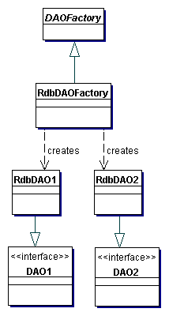
Figure 9.3 Factory for Data Access Object strategy using Factory Method
When the underlying storage is subject to change from one implementation to another, this strategy may be implemented using the Abstract Factory pattern. The Abstract Factory can in turn build on and use the Factory Method implementation, as suggested in Design Patterns: Elements of Reusable Object-Oriented Software [GoF]. In this case, this strategy provides an abstract DAO factory object (Abstract Factory) that can construct various types of concrete DAO factories, each factory supporting a different type of persistent storage implementation. Once you obtain the concrete DAO factory for a specific implementation, you use it to produce DAOs supported and implemented in that implementation.
The class diagram for this strategy is shown in Figure 9.4. This class diagram shows a base DAO factory, which is an abstract class that is inherited and implemented by different concrete DAO factories to support storage implementation-specific access. The client can obtain a concrete DAO factory implementation such as RdbDAOFactory and use it to obtain concrete DAOs that work with that specific storage implementation. For example, the data client can obtain an RdbDAOFactory and use it to get specific DAOs such as RdbCustomerDAO, RdbAccountDAO, and so forth. The DAOs can extend and implement a generic base class (shown as DAO1 and DAO2) that specifically describe the DAO requirements for the business object it supports. Each concrete DAO is responsible for connecting to the data source and obtaining and manipulating data for the business object it supports.
The sample implementation for the DAO pattern and its strategies is shown in the "Sample Code" section of this chapter.
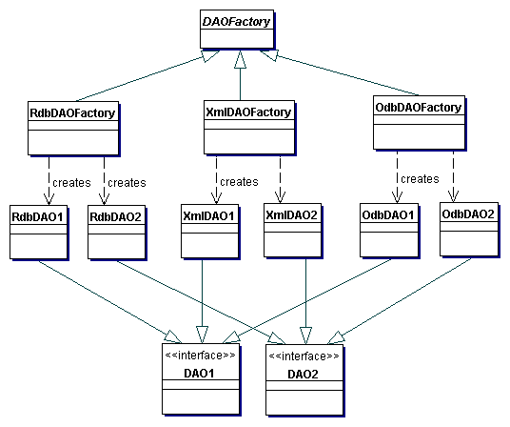
Figure 9.4 Factory for Data Access Object strategy using Abstract Factory
The sequence diagram describing the interactions for this strategy is shown in Figure 9.5.
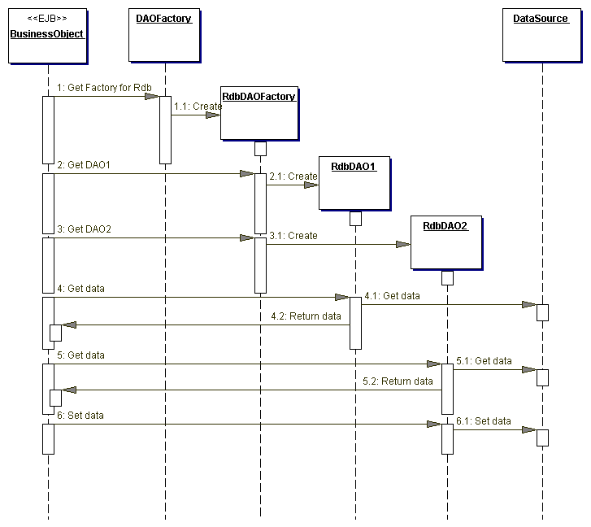
Figure 9.5 Factory for Data Access Objects using Abstract Factory sequence diagram

Consequences
- Enables Transparency
Business objects can use the data source without knowing the specific details of the data source's implementation. Access is transparent because the implementation details are hidden inside the DAO.
- Enables Easier Migration
A layer of DAOs makes it easier for an application to migrate to a different database implementation. The business objects have no knowledge of the underlying data implementation. Thus, the migration involves changes only to the DAO layer. Further, if employing a factory strategy, it is possible to provide a concrete factory implementation for each underlying storage implementation. In this case, migrating to a different storage implementation means providing a new factory implementation to the application.
- Reduces Code Complexity in Business ObjectsBecause the DAOs manage all the data access complexities, it simplifies the code in the business objects and other data clients that use the DAOs. All implementation-related code (such as SQL statements) is contained in the DAO and not in the business object. This improves code readability and development productivity.
- Centralizes All Data Access into a Separate Layer
Because all data access operations are now delegated to the DAOs, the separate data access layer can be viewed as the layer that can isolate the rest of the application from the data access implementation. This centralization makes the application easier to maintain and manage.
- Not Useful for Container-Managed Persistence
Because the EJB container manages entity beans with container-managed persistence (CMP), the container automatically services all persistent storage access. Applications using container-managed entity beans do not need a DAO layer, since the application server transparently provides this functionality. However, DAOs are still useful when a combination of CMP (for entity beans) and BMP (for session beans, servlets) is required.
- Adds Extra Layer
The DAOs create an additional layer of objects between the data client and the data source that need to be designed and implemented to leverage the benefits of this pattern. But the benefit realized by choosing this approach pays off for the additional effort.
- Needs Class Hierarchy Design
When using a factory strategy, the hierarchy of concrete factories and the hierarchy of concrete products produced by the factories need to be designed and implemented. This additional effort needs to be considered if there is sufficient justification warranting such flexibility. This increases the complexity of the design. However, you can choose to implement the factory strategy starting with the Factory Method pattern first, and then move towards the Abstract Factory if necessary.

Sample Code

Implementing Data Access Object pattern
An example DAO code for a persistent object that represents Customer information is shown in Example 9.4. The CloudscapeCustomerDAO creates a Customer Transfer Object when the findCustomer() method is invoked.
The sample code to use the DAO is shown in Example 9.6. The class diagram for this example is shown in Figure 9.6.
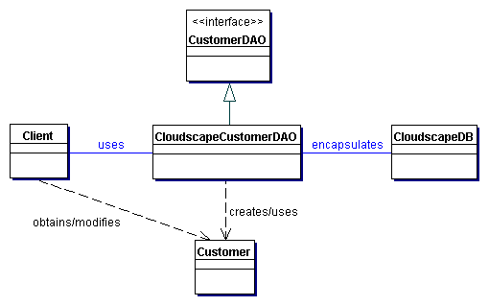
Figure 9.6 Implementing the DAO pattern

Implementing Factory for Data Access Objects Strategy

Using Factory Method Pattern
Consider an example where we are implementing this strategy in which a DAO factory produces many DAOs for a single database implementation (e.g., Oracle). The factory produces DAOs such as CustomerDAO, AccountDAO, OrderDAO, and so forth. The class diagram for this example is shown in Figure 9.7.
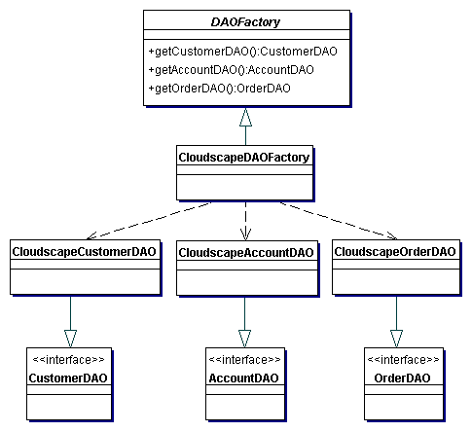
Figure 9.7 Implementing the Factory for DAO strategy using Factory Method
The example code for the DAO factory (CloudscapeDAOFactory) is listed in Example 9.2.

Using Abstract Factory Pattern
Consider an example where we are considering implementing this strategy for three different databases. In this case, the Abstract Factory pattern can be employed. The class diagram for this example is shown in Figure 9.8. The sample code in Example 9.1 shows code excerpt for the abstract DAOFactory class. This factory produces DAOs such as CustomerDAO, AccountDAO, OrderDAO, and so forth. This strategy uses the Factory Method implementation in the factories produced by the Abstract Factory.
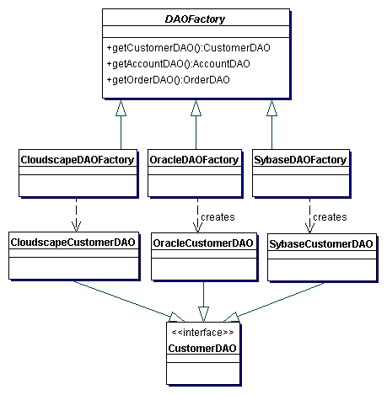
Figure 9.8 Implementing the Factory for DAO strategy using Abstract Factory Example 9.1 Abstract DAOFactory Class
// Abstract class DAO Factory
public abstract class DAOFactory {

// List of DAO types supported by the factory
public static final int CLOUDSCAPE = 1;
public static final int ORACLE = 2;
public static final int SYBASE = 3;
...

// There will be a method for each DAO that can be
// created. The concrete factories will have to
// implement these methods.
public abstract CustomerDAO getCustomerDAO();
public abstract AccountDAO getAccountDAO();
public abstract OrderDAO getOrderDAO();
...

public static DAOFactory getDAOFactory(
int whichFactory) {

switch (whichFactory) {
case CLOUDSCAPE:
return new CloudscapeDAOFactory();
case ORACLE :
return new OracleDAOFactory();
case SYBASE :
return new SybaseDAOFactory();
...
default :
return null;
}
}
}

The sample code for CloudscapeDAOFactory is shown in Example 9.2. The implementation for OracleDAOFactory and SybaseDAOFactory are similar except for specifics of each implementation, such as JDBC driver, database URL, and differences in SQL syntax, if any.
Example 9.2 Concrete DAOFactory Implementation for Cloudscape
// Cloudscape concrete DAO Factory implementation
import java.sql.*;

public class CloudscapeDAOFactory extends DAOFactory {
public static final String DRIVER=
"COM.cloudscape.core.RmiJdbcDriver";
public static final String DBURL=
"jdbc:cloudscape:rmi://localhost:1099/CoreJ2EEDB";

// method to create Cloudscape connections
public static Connection createConnection() {
// Use DRIVER and DBURL to create a connection
// Recommend connection pool implementation/usage
}
public CustomerDAO getCustomerDAO() {
// CloudscapeCustomerDAO implements CustomerDAO
return new CloudscapeCustomerDAO();
}
public AccountDAO getAccountDAO() {
// CloudscapeAccountDAO implements AccountDAO
return new CloudscapeAccountDAO();
}
public OrderDAO getOrderDAO() {
// CloudscapeOrderDAO implements OrderDAO
return new CloudscapeOrderDAO();
}
...
}

The CustomerDAO interface shown in Example 9.3 defines the DAO methods for Customer persistent object that are implemented by all concrete DAO implementations, such as CloudscapeCustomerDAO, OracleCustomerDAO, and SybaseCustomerDAO. Similar, but not listed here, are AccountDAO and OrderDAO interfaces that define the DAO methods for Account and Order business objects respectively.
Example 9.3 Base DAO Interface for Customer
// Interface that all CustomerDAOs must support
public interface CustomerDAO {
public int insertCustomer(...);
public boolean deleteCustomer(...);
public Customer findCustomer(...);
public boolean updateCustomer(...);
public RowSet selectCustomersRS(...);
public Collection selectCustomersTO(...);
...
}

The CloudscapeCustomerDAO implements the CustomerDAO as shown in Example 9.4. The implementation of other DAOs, such as CloudscapeAccountDAO, CloudscapeOrderDAO, OracleCustomerDAO, OracleAccountDAO, and so forth, are similar.
Example 9.4 Cloudscape DAO Implementation for Customer
// CloudscapeCustomerDAO implementation of the
// CustomerDAO interface. This class can contain all
// Cloudscape specific code and SQL statements.
// The client is thus shielded from knowing
// these implementation details.

import java.sql.*;

public class CloudscapeCustomerDAO implements
CustomerDAO {

public CloudscapeCustomerDAO() {
// initialization
}

// The following methods can use
// CloudscapeDAOFactory.createConnection()
// to get a connection as required

public int insertCustomer(...) {
// Implement insert customer here.
// Return newly created customer number
// or a -1 on error
}

public boolean deleteCustomer(...) {
// Implement delete customer here
// Return true on success, false on failure
}

public Customer findCustomer(...) {
// Implement find a customer here using supplied
// argument values as search criteria
// Return a Transfer Object if found,
// return null on error or if not found
}

public boolean updateCustomer(...) {
// implement update record here using data
// from the customerData Transfer Object
// Return true on success, false on failure or
// error
}

public RowSet selectCustomersRS(...) {
// implement search customers here using the
// supplied criteria.
// Return a RowSet.
}

public Collection selectCustomersTO(...) {
// implement search customers here using the
// supplied criteria.
// Alternatively, implement to return a Collection
// of Transfer Objects.
}
...
}

The Customer Transfer Object class is shown in Example 9.5. This is used by the DAOs to send and receive data from the clients. The usage of Transfer Objects is discussed in detail in the Transfer Object pattern.
Example 9.5 Customer Transfer Object
public class Customer implements java.io.Serializable {
// member variables
int CustomerNumber;
String name;
String streetAddress;
String city;
...

// getter and setter methods...
...
}

Example 9.6 shows the usage of the DAO factory and the DAO. If the implementation changes from Cloudscape to another product, the only required change is the getDAOFactory() method call to the DAO factory to obtain a different factory.
Example 9.6 Using a DAO and DAO Factory - Client Code
...
// create the required DAO Factory
DAOFactory cloudscapeFactory =
DAOFactory.getDAOFactory(DAOFactory.DAOCLOUDSCAPE);

// Create a DAO
CustomerDAO custDAO =
cloudscapeFactory.getCustomerDAO();

// create a new customer
int newCustNo = custDAO.insertCustomer(...);

// Find a customer object. Get the Transfer Object.
Customer cust = custDAO.findCustomer(...);

// modify the values in the Transfer Object.
cust.setAddress(...);
cust.setEmail(...);
// update the customer object using the DAO
custDAO.updateCustomer(cust);

// delete a customer object
custDAO.deleteCustomer(...);
// select all customers in the same city
Customer criteria=new Customer();
criteria.setCity("New York");
Collection customersList =
custDAO.selectCustomersTO(criteria);
// returns customersList - collection of Customer
// Transfer Objects. iterate through this collection to
// get values.

...

Related Patterns
- Transfer Object
A DAO uses Transfer Objects to transport data to and from its clients.
- Factory Method [GoF] and Abstract Factory [GoF]
The Factory for Data Access Objects Strategy uses the Factory Method pattern to implement the concrete factories and its products (DAOs). For added flexibility, the Abstract Factory pattern may be employed as discussed in the strategies.
- Broker [POSA1]
The DAO pattern is related to the Broker pattern, which describes approaches for decoupling clients and servers in distributed systems. The DAO pattern more specifically applies this pattern to decouple the resource tier from clients in another tier, such as the business or presentation tier
Contact Us© 2001-2002 Sun Microsystems, Inc. All Rights Reserved.

